**Python Day 1:**

**Task 1:** Check Palindrome using single word

**Python Code:**

a = input("Enter the word:") #Getting the input from user

A = a.casefold() #Casefold() is used to converts a string into lower case

B = ""

for i in A:

B = i + B

if A == B: #Checking both strings are equal or not using comparison operator

print(f"{A} is Palindrome")

else:

print(f"{A} is not a Palindrome")

# Using built-in method

a = input("Enter the word:") #Getting the input from user

A = a.casefold() #Casefold() is used to converts a string into lower case

B = reversed(A)

if list(A) == list(B): #Checking both strings are equal or not using comparison operator

print(f"{A} is Palindrome")

else:

print(f"{A} is not a Palindrome")

**Output:**

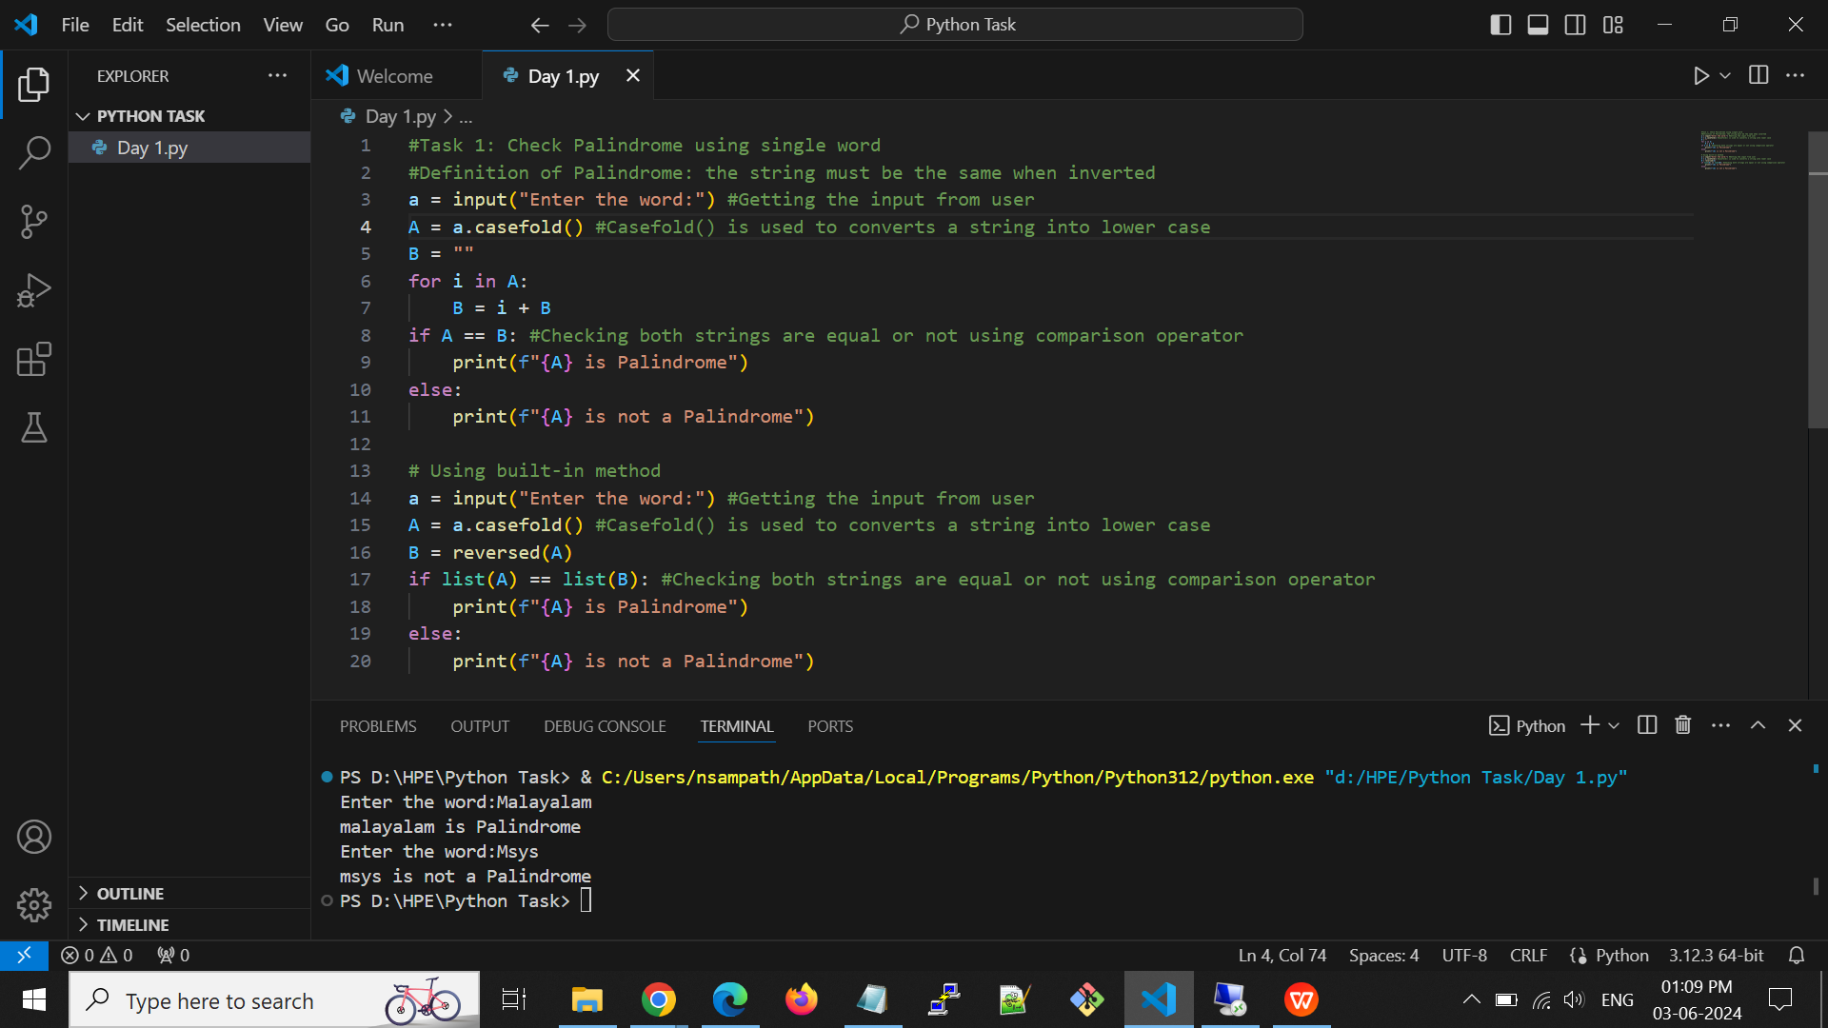

**Task 2**: Convert Second letter as UpperCase using single word

**Python Code:**

#Task 2: Convert Second letter as UpperCase using single word

A = input("Enter the word:") #Input from user

B = A[:1] + A[1].upper() + A[2:] #A[1].upper it convert lower case to upper case of index value 1 of A.

print(B)

**Output:**

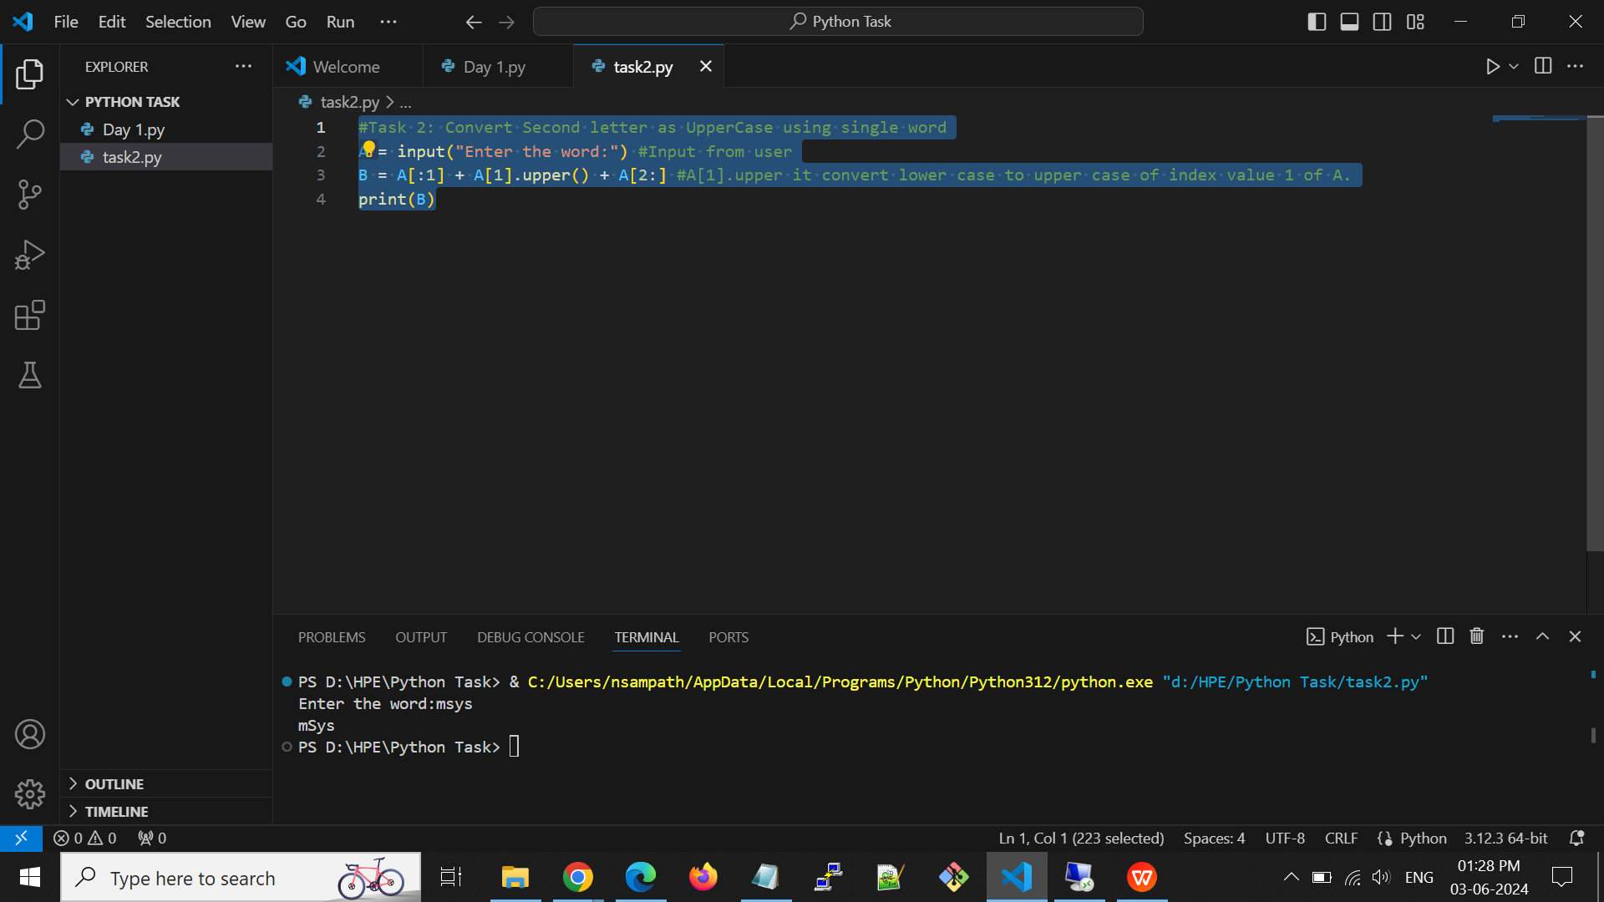

**Python Day 2:-**

**List:-**

* Lists are used to store multiple items in a single variable.
* List items are ordered, changeable, and allow duplicate values.
* Default list value is an empty list [].

**List Methods:-**

**len()** - It returns the total length of list.

**E.g:**

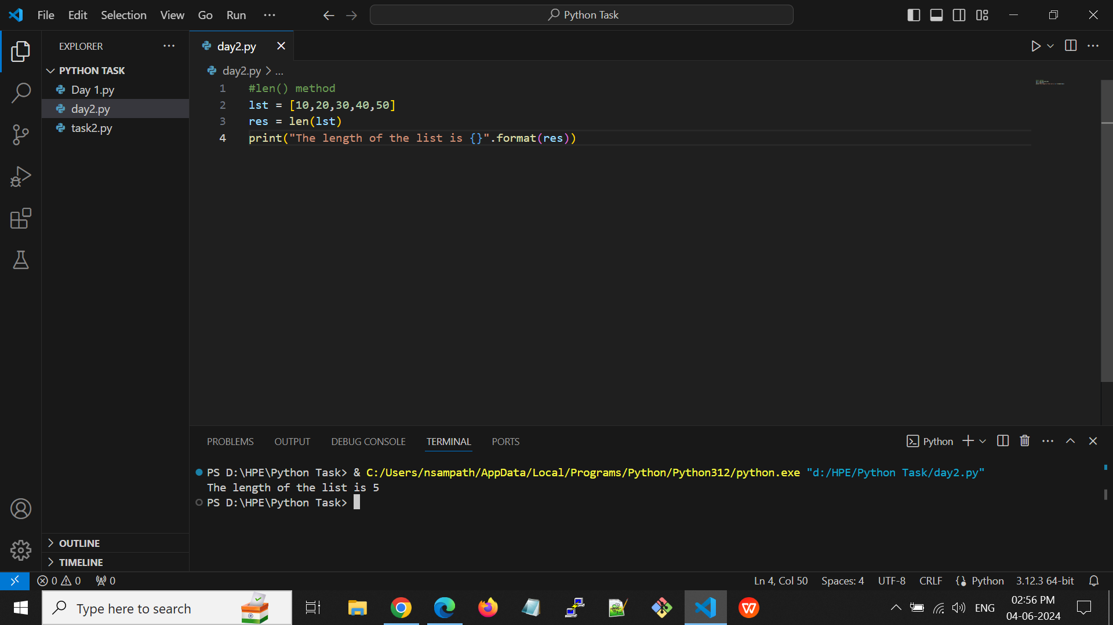

**Output:-**



**max()** - Returns the largest element of the list.

**E.g:**

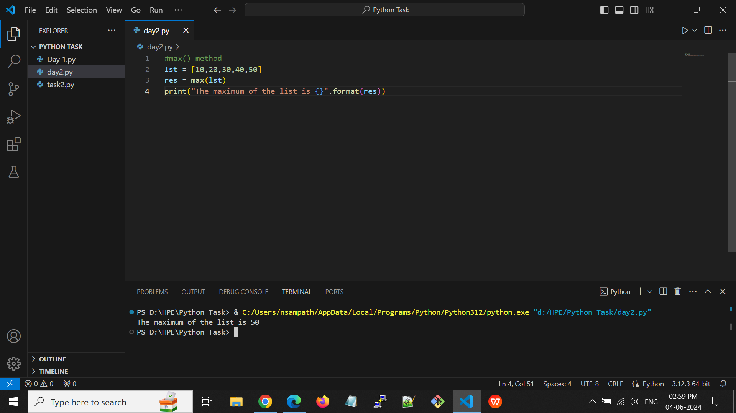

**Output:**



**min()** - Returns the smallest element of the list.

**E.g:**

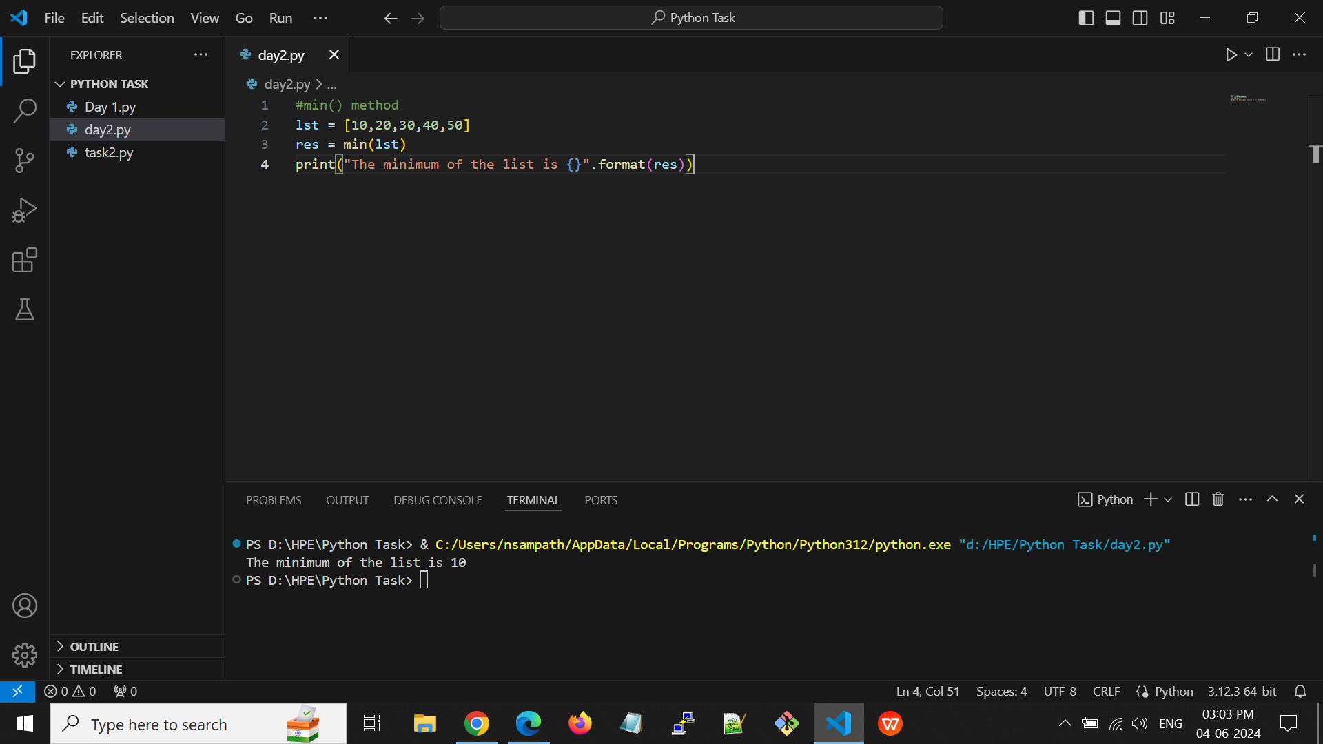

**Output:**



**sum()** - Returns the sum of the elements of the list.

**E.g:**

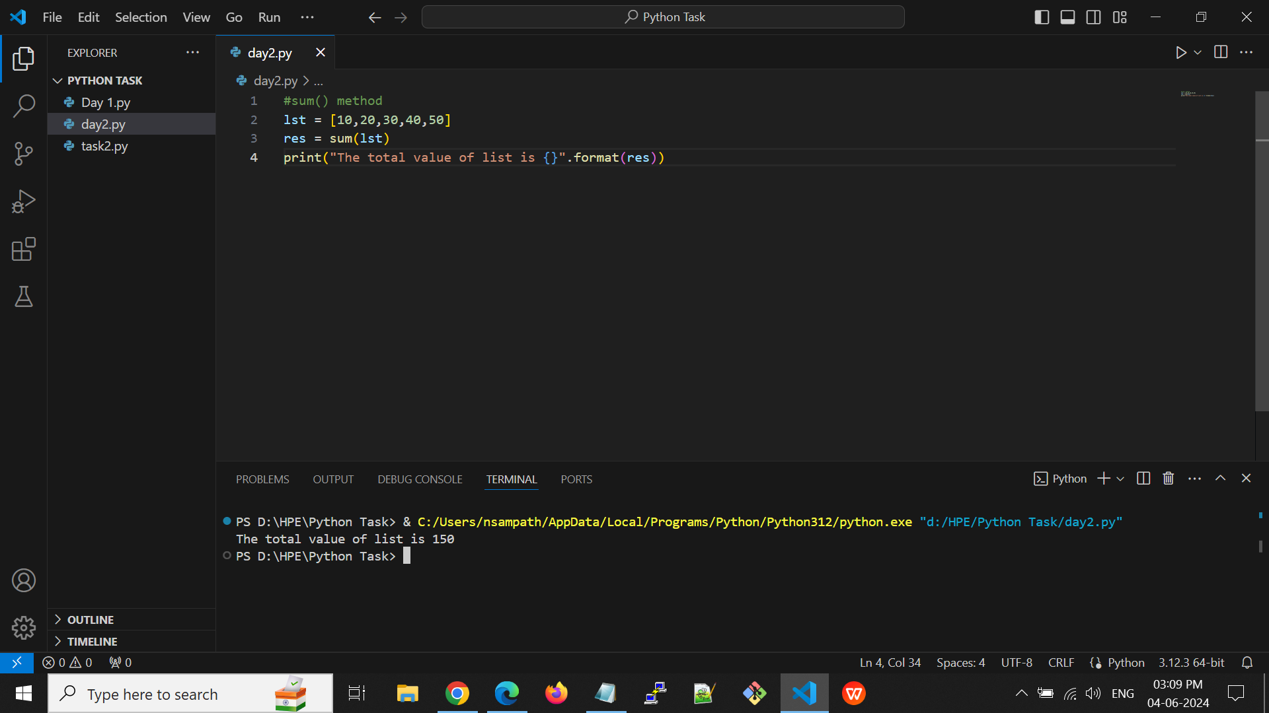

**Output:**



**append()** - Adds a new element at the end of the list.

**E.g:**

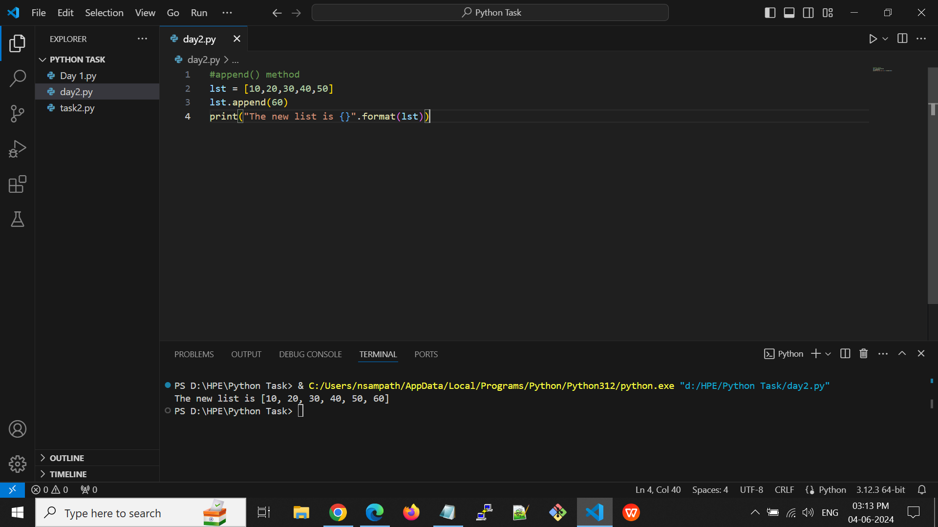

**Output:**



**insert()** - Adds an element at the specified position

**E.g:**

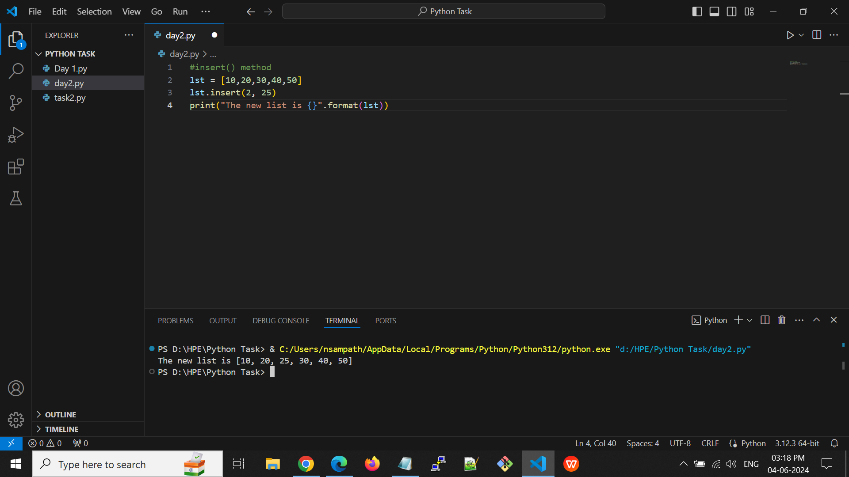

**Output:**

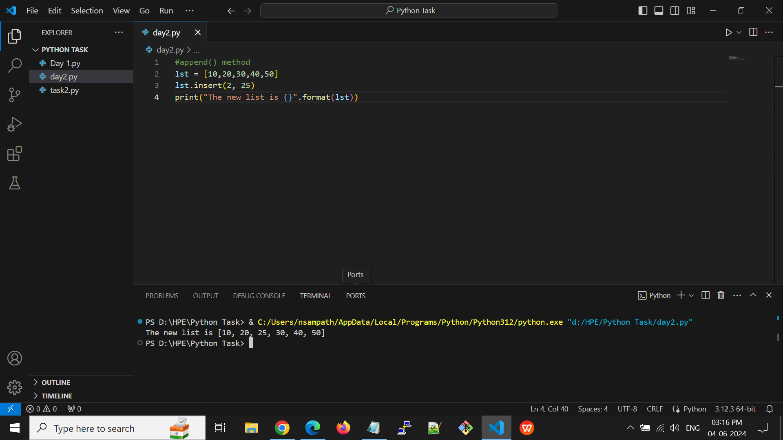

**remove()** - Removes the item with the specified value

It will remove the first occurrence of the elements

**E.g:**

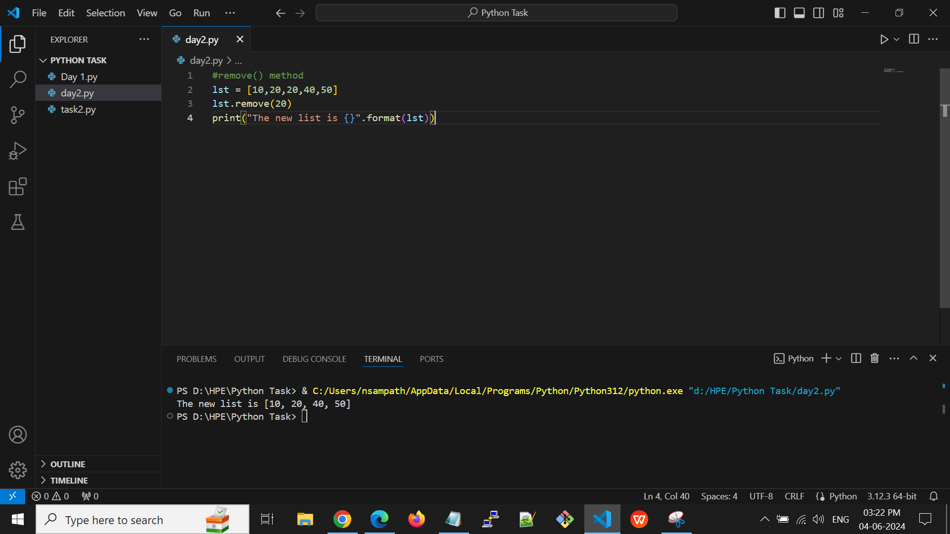

**Output:**



**count(**) - Returns the number of elements with the specified value

**E.g:**

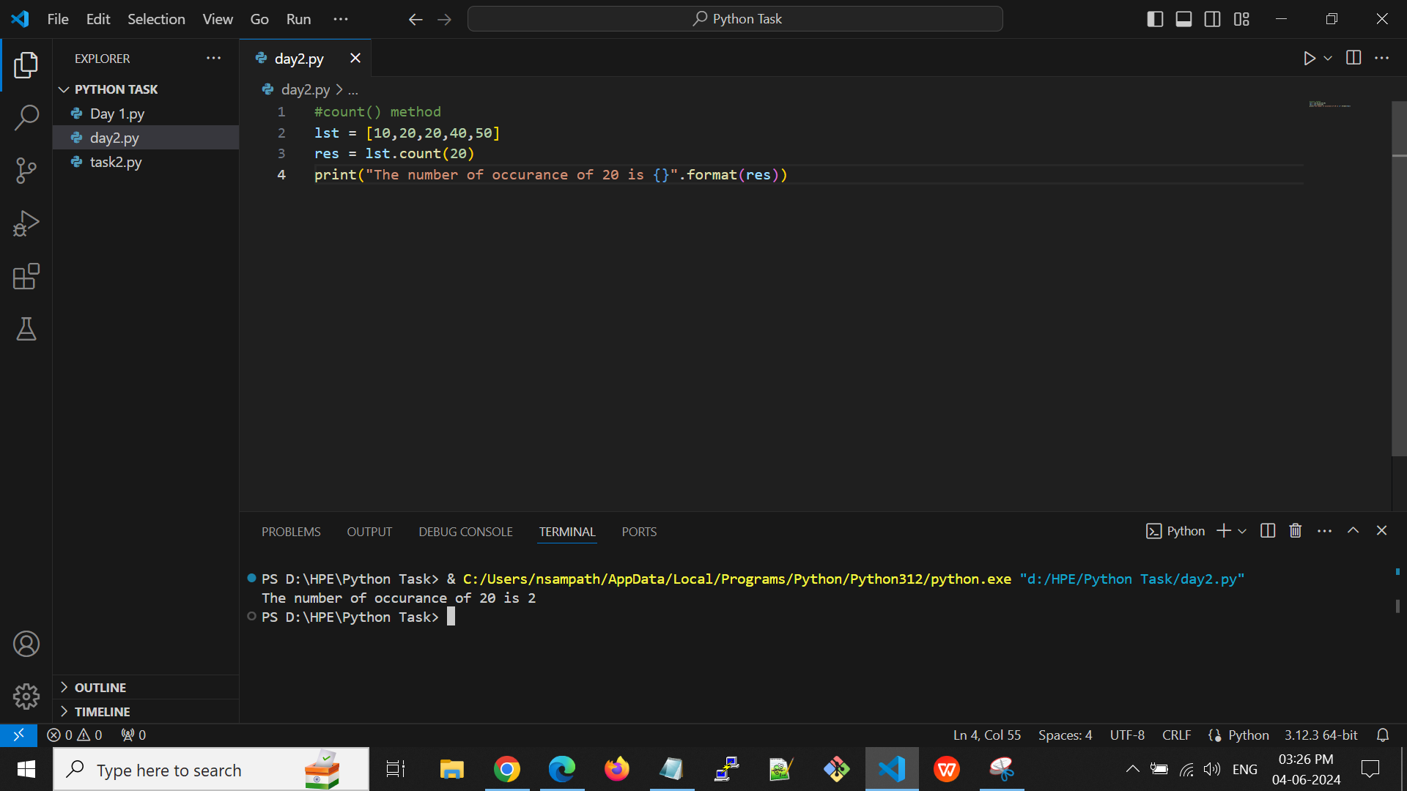

**Output:**



**index()** - Returns the index of the first element with the specified value.

**E.g:**

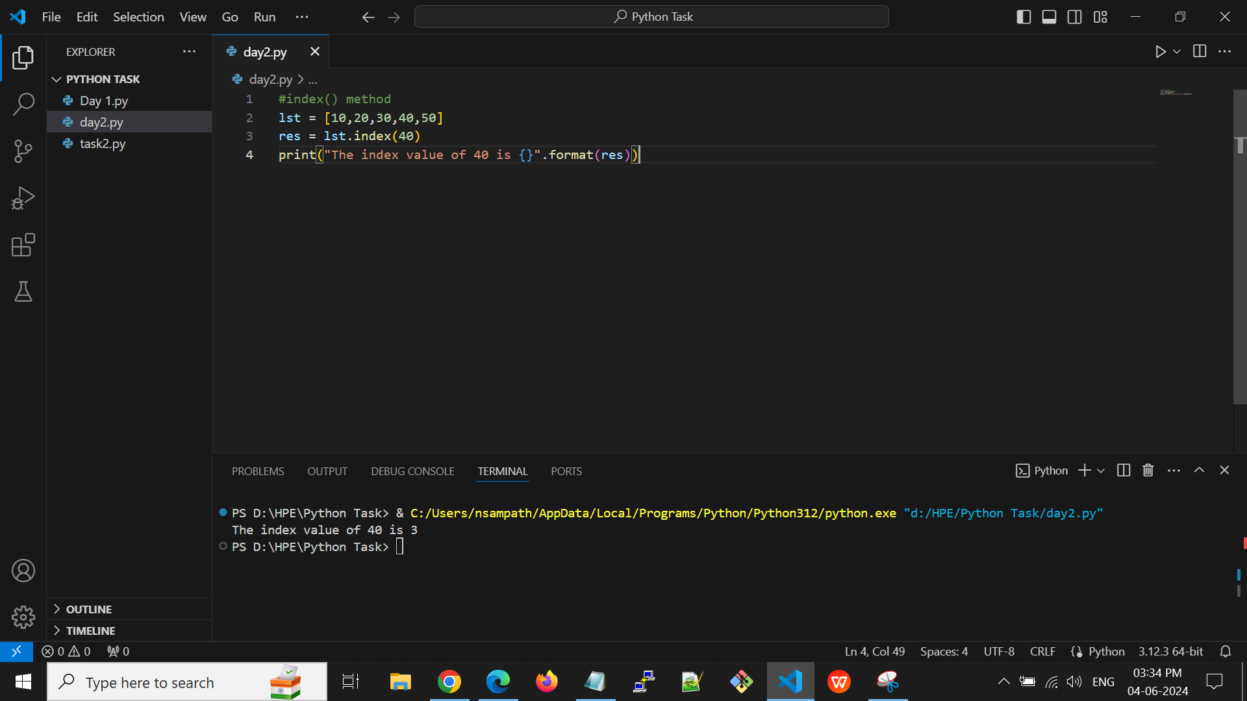

**Output:**

.

**reverse()** - Reverses the order of the list

**E.g:**

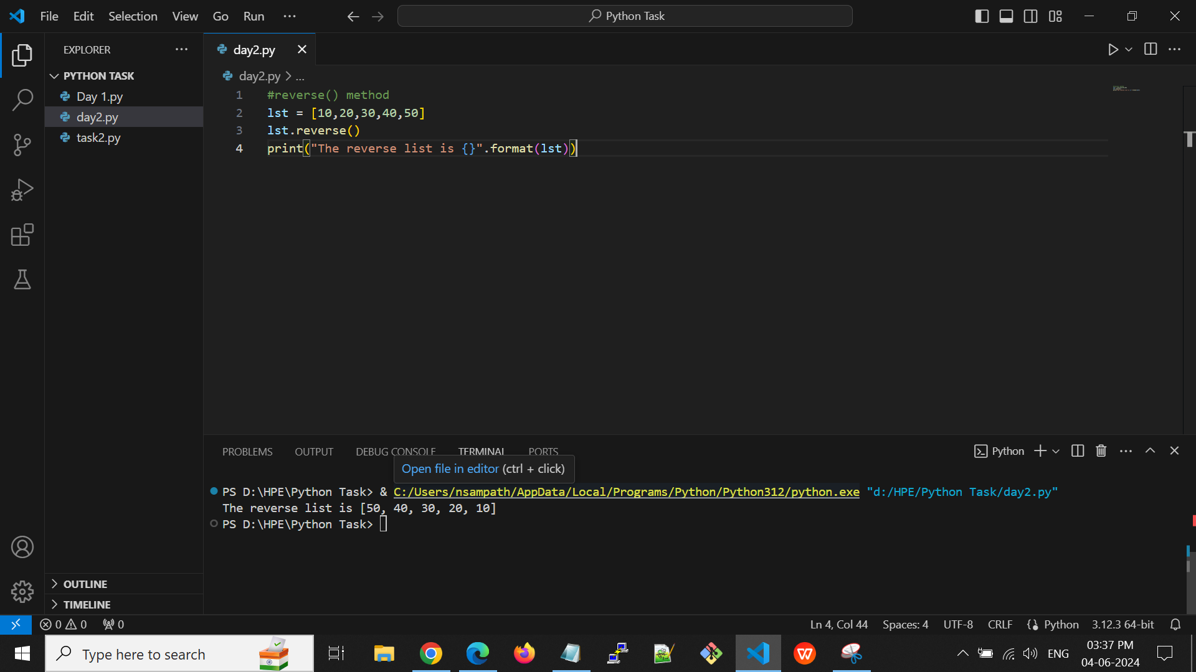

**Output:**



**pop()** - Removes the element at the specified position.

if no argument is provided, the last element in the list

**E.g:**

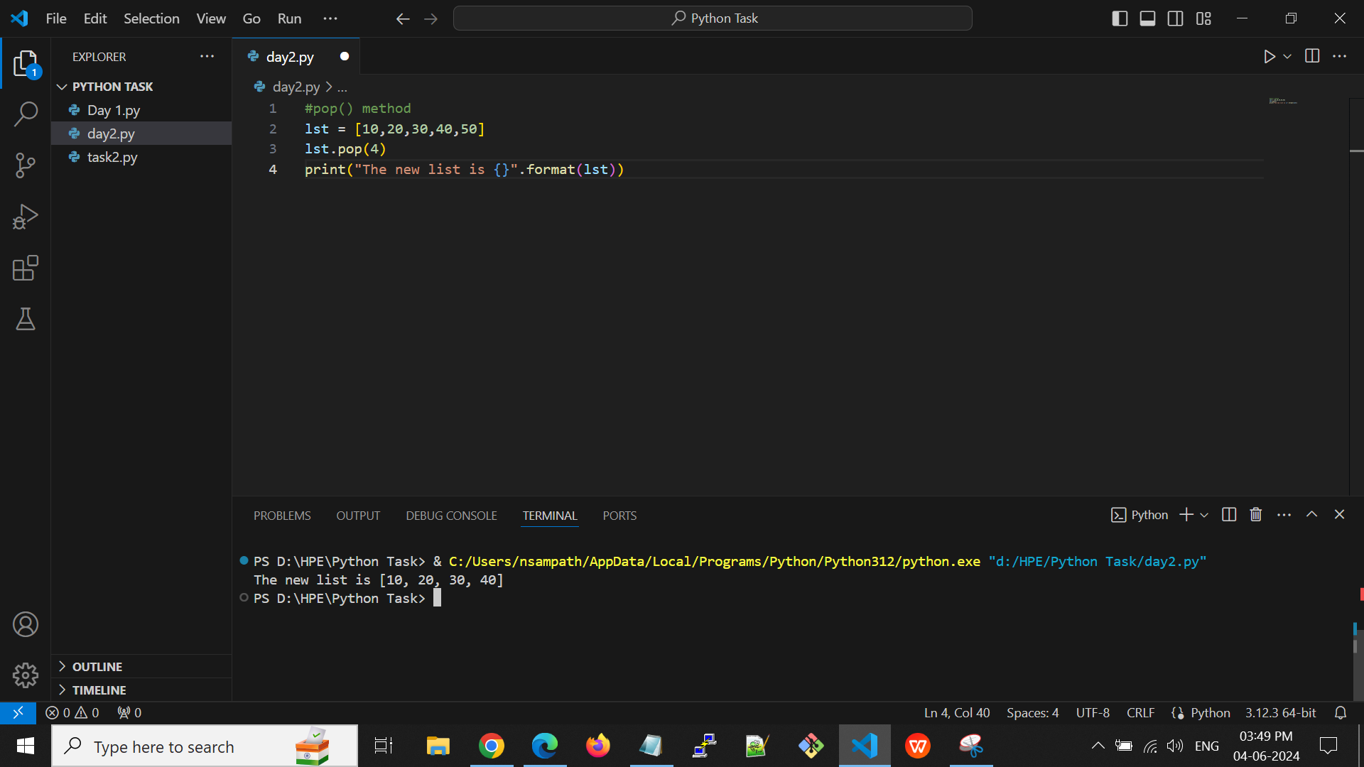

**Output:**

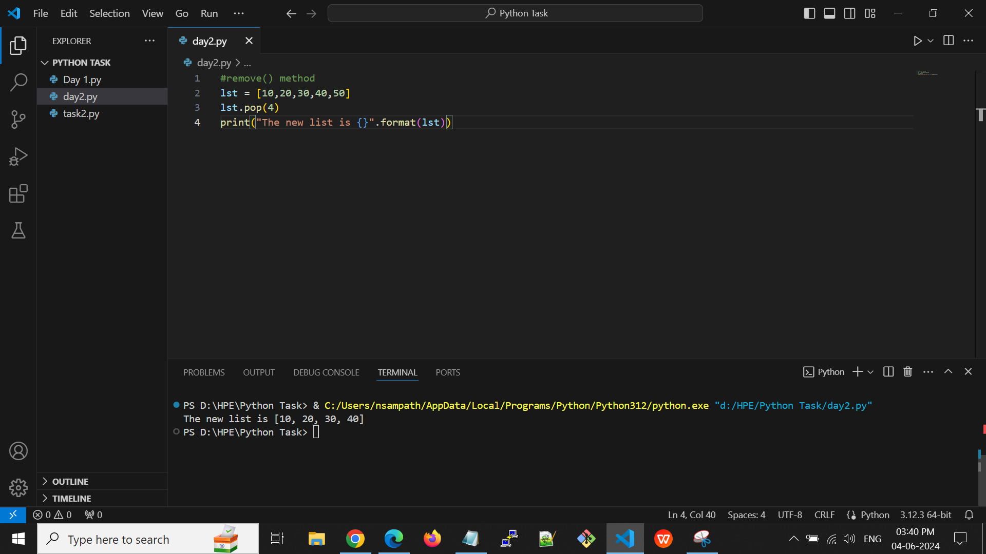

**Tuples:-**

* Tuples are used to store multiple items in a single variable.
* Tuple items are ordered, unchangeable, and allow duplicate values.
* The default tuple value is empty tuple ()

**Tuples Methods:-**

**len() -** It returns the total length of tuples.

**E.g:**

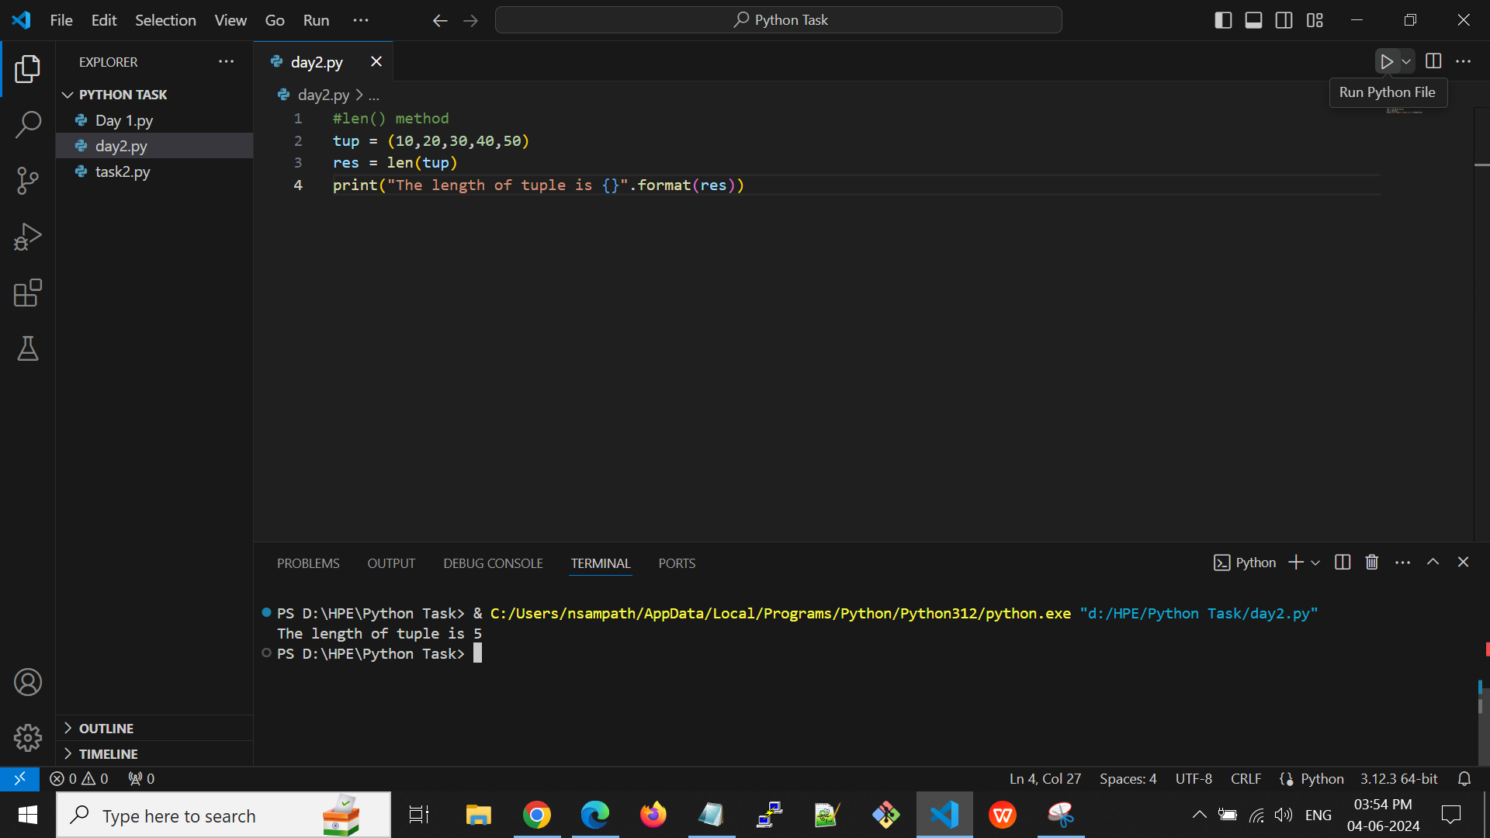

**Output:**



**min() -** It returns the smallest of tuples.

**E.g:**

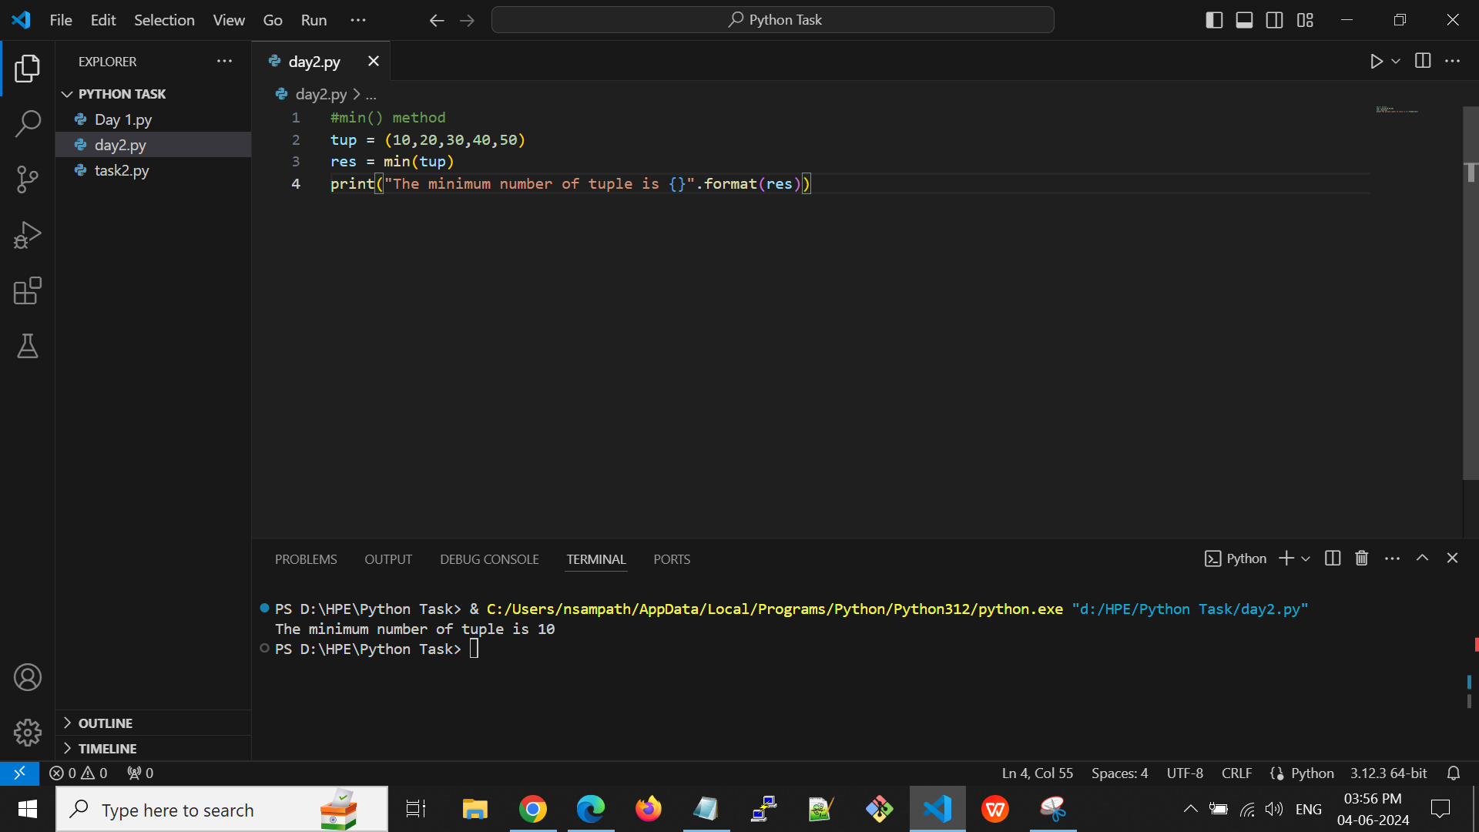

**Output:**



**max() -** It returns the largest of tuples.

**E.g:**

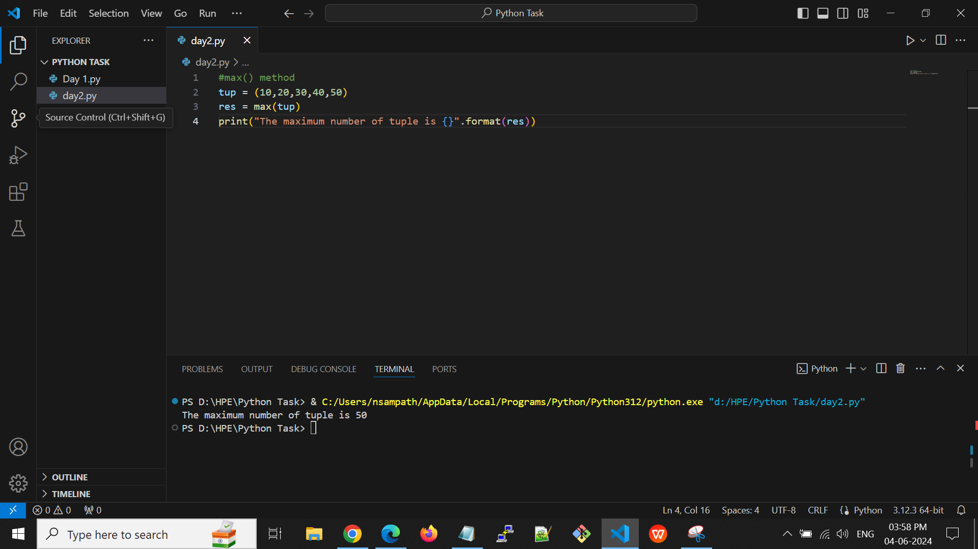

**Output:**



**index() -** Returns the index of the first element with the specified value.

**E.g:**

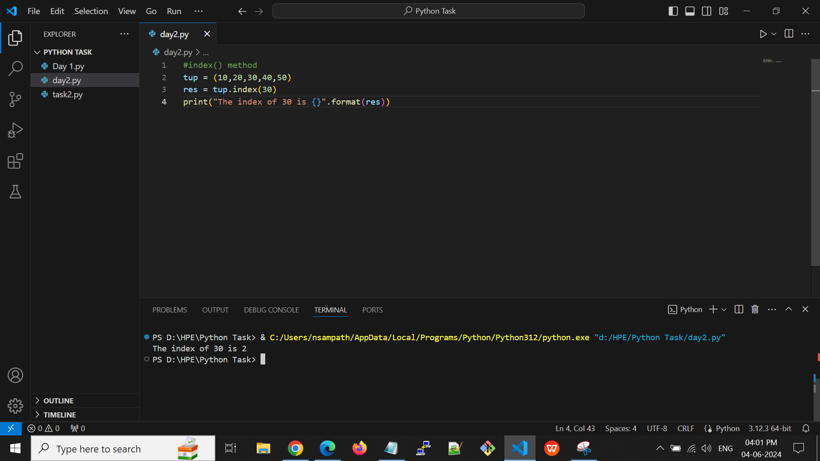

**Output:**



**count()** - Returns the number of times a specified value occurs in a tuple.

**E.g:**

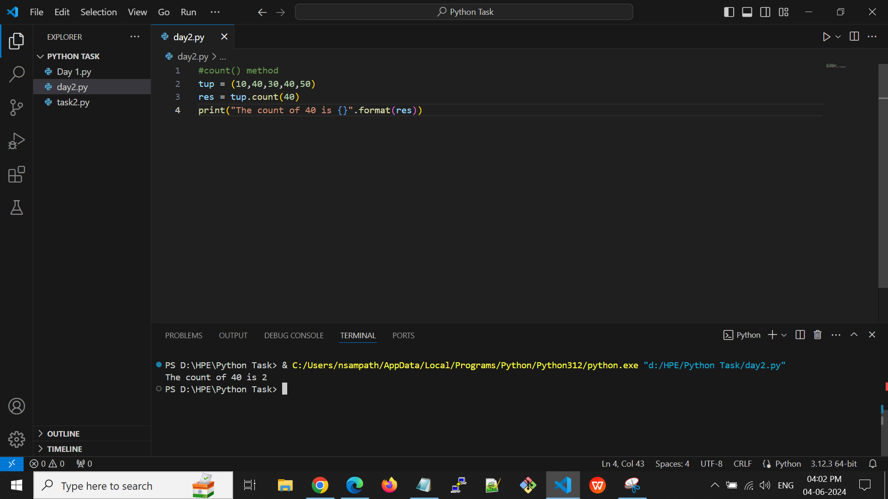

**Output:**



**Set:-**

* Sets are used to store multiple items in a single variable.
* Set items are unordered, unchangeable, and do not allow duplicate values.

**Set methods:**

**add()** - Adds an element to the set.

**E.g:**

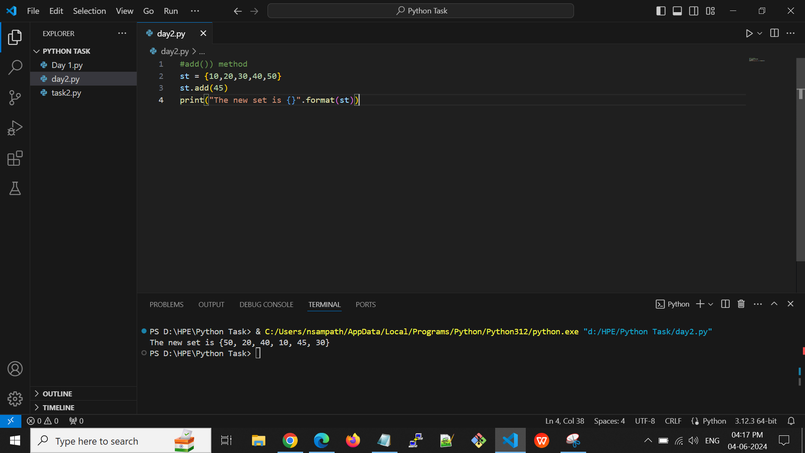

**Output:**



**clear()** - Removes all the elements from the set.

**E.g:**

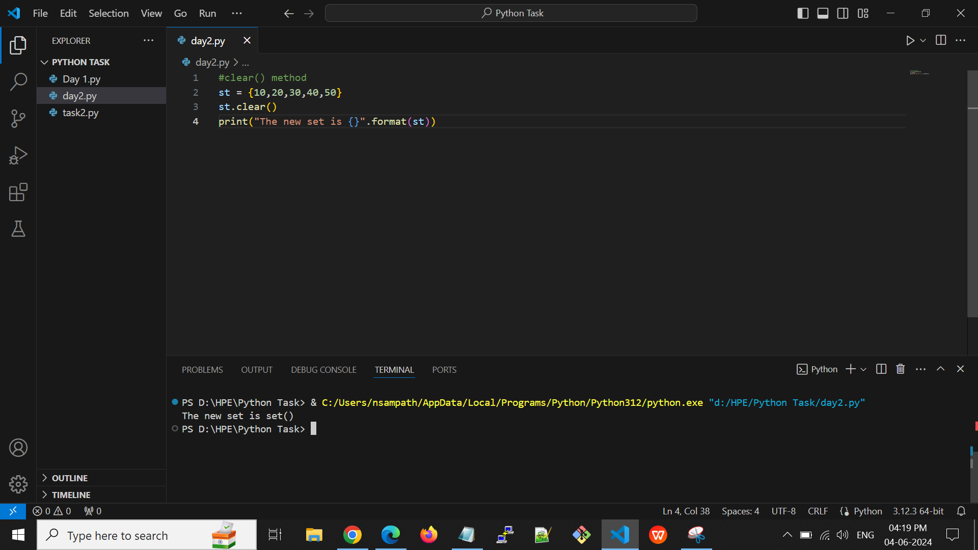

**Output:**



**copy()** - Returns a copy of the set

**E.g:**

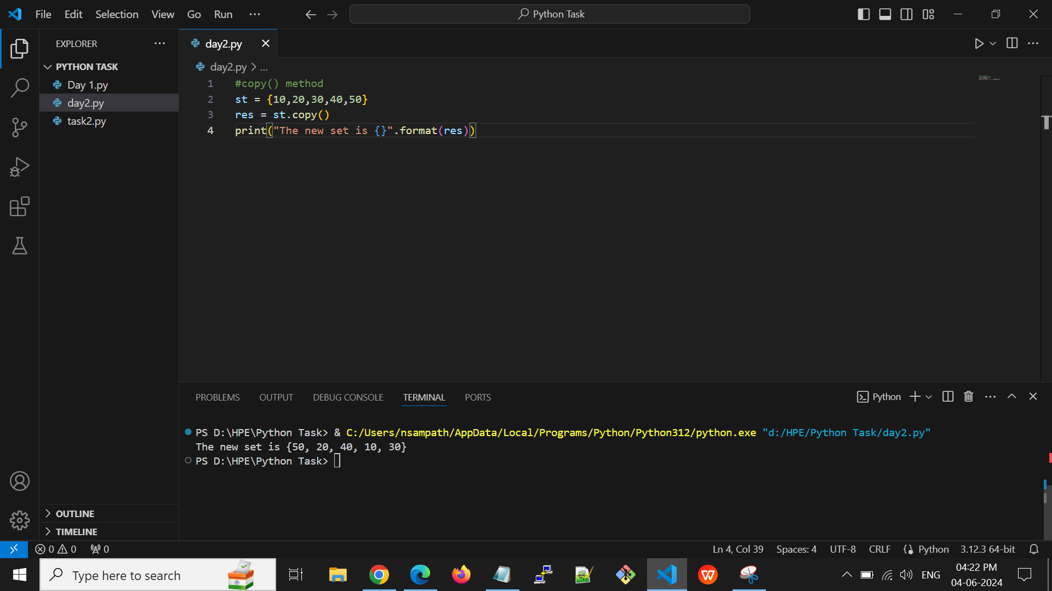

**Output:**



**difference()** - Returns a set containing the difference between two or more sets.

**E.g:**

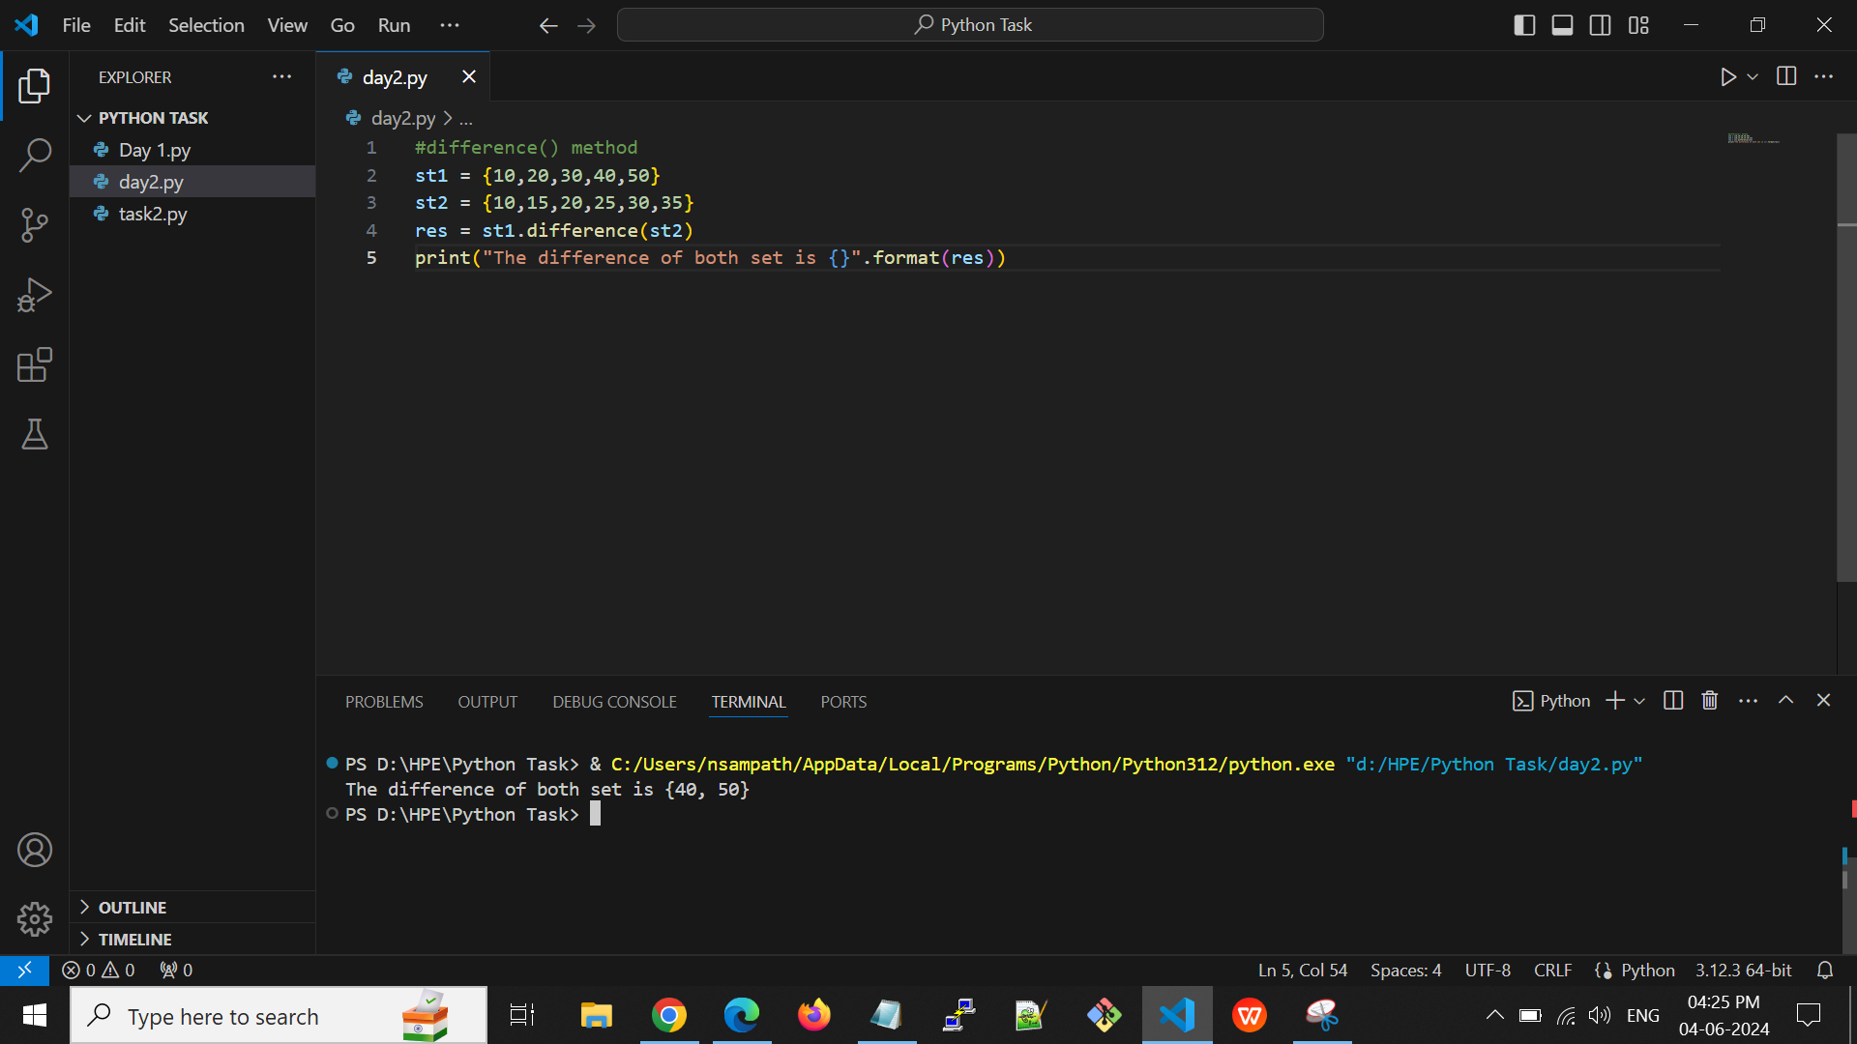

**Output:**



**discard()** - Remove the specified item.

**E.g:**

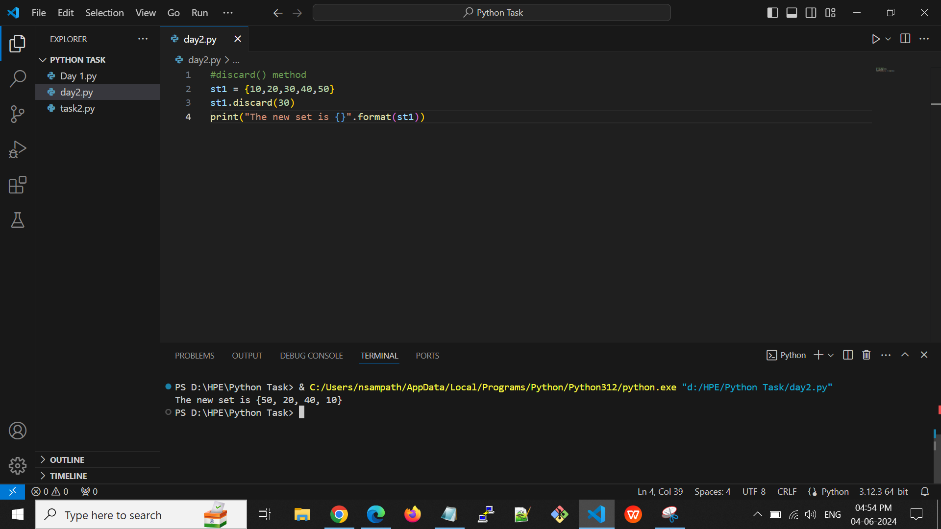

**Output:**



**intersection()** - Returns a set, that is the intersection of two other sets.

**E.g:**

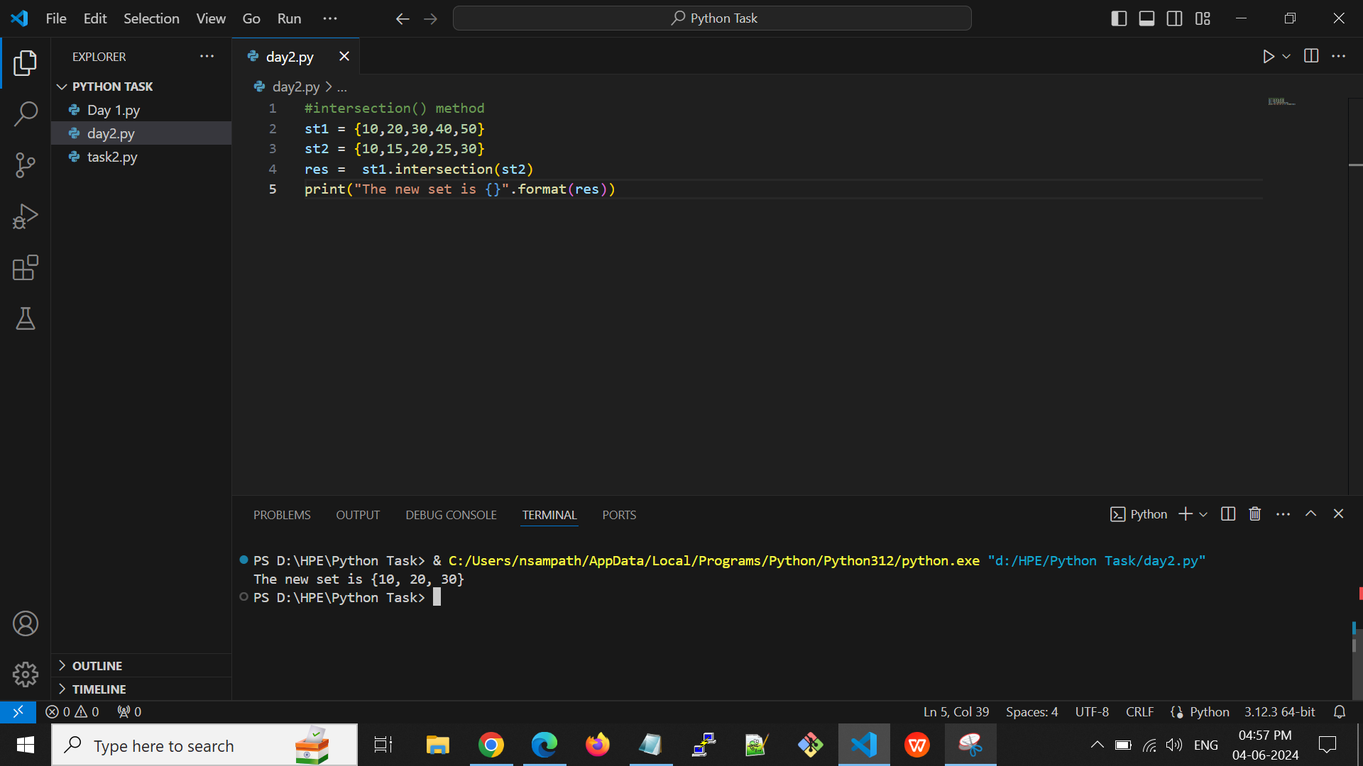

**Output:**



**isdisjoint()** - Returns whether two sets have an intersection or not.

**E.g:**

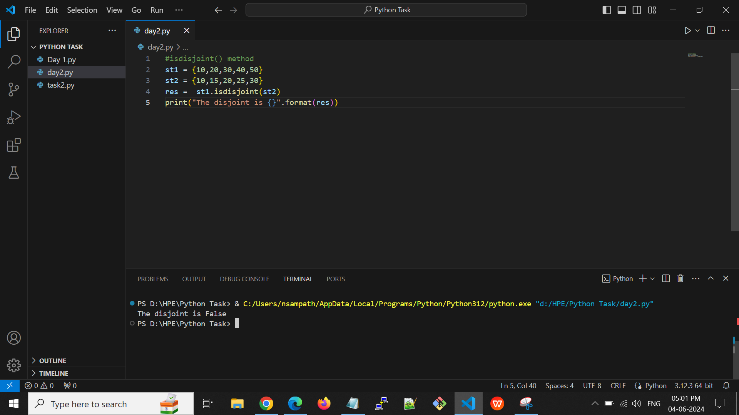

**Output:**



**issubset()** - Returns whether another set contains this set or not. Returns whether all items in this set is present in other, specified set(s)

**E.g:**

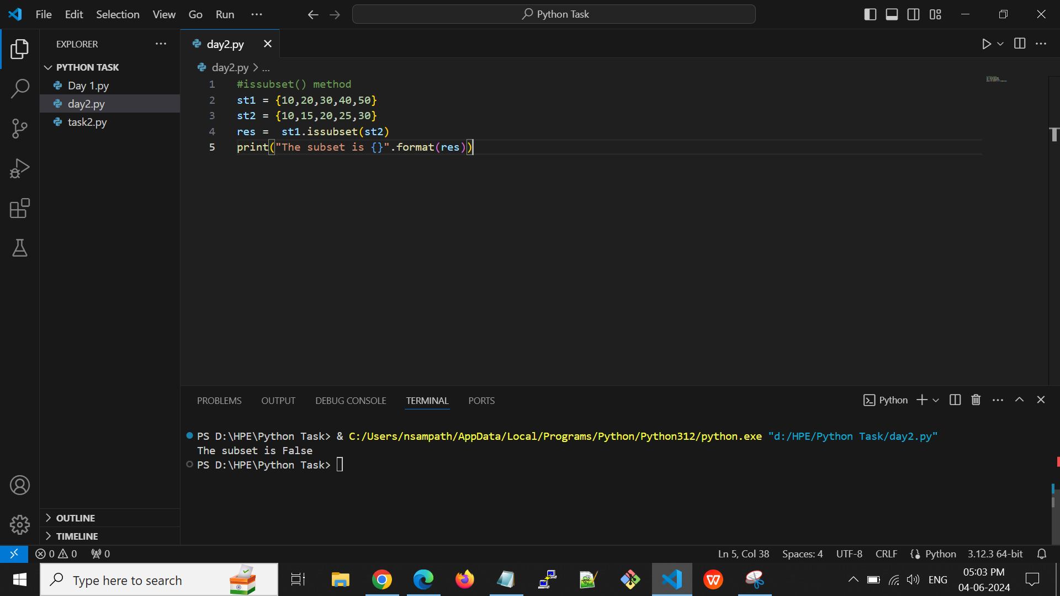

**Output:**



**issuperset()** - Returns whether this set contains another set or not Returns whether all items in other, specified set(s) is present in this set.

**E.g:**

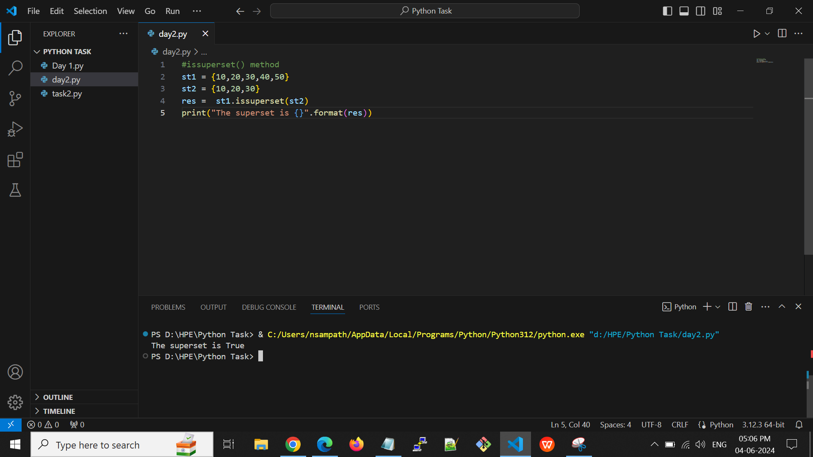

**Output:**



**union()** - Return a set containing the union of sets.

**E.g:**

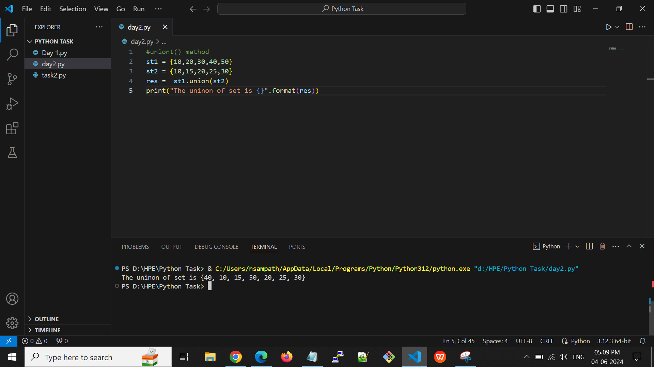

**Output:**



**update()** - Update the set with the union of this set and others.

**E.g:**

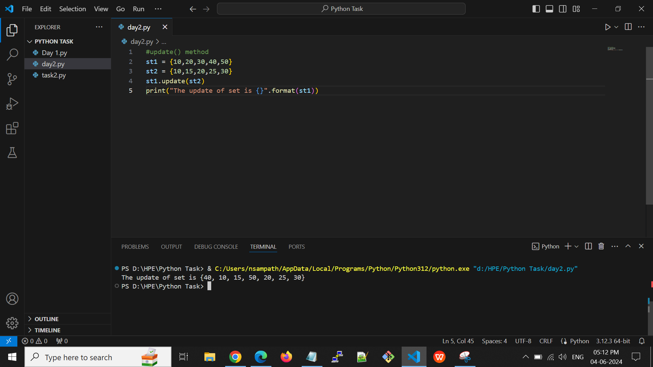

**Output:**



**Dictionary:-**

* Dictionaries are used to store data values in key:value pairs.
* A dictionary is a collection which is ordered, changeable and do not allow duplicates.

**Dictionary Methods:**

**len()** - Returns the length of the dictionary.

**E.g:**

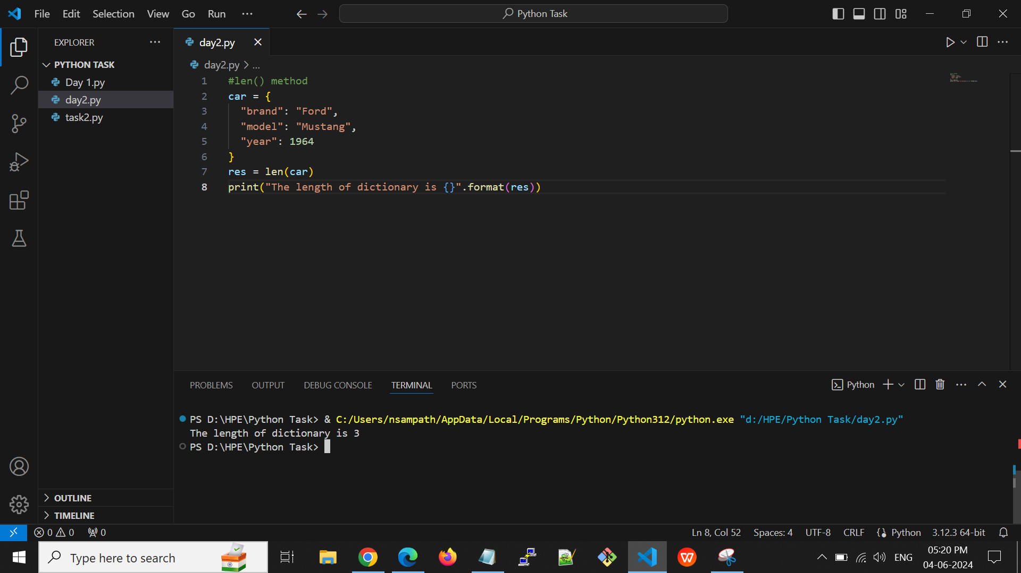

**Output:**

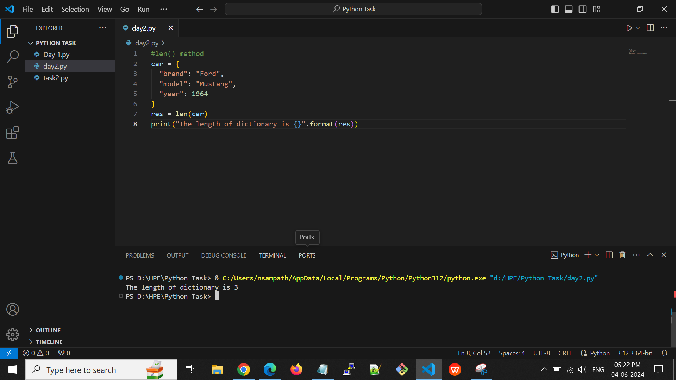

**max() -** Return maximum key of dictionary.

**E.g:**

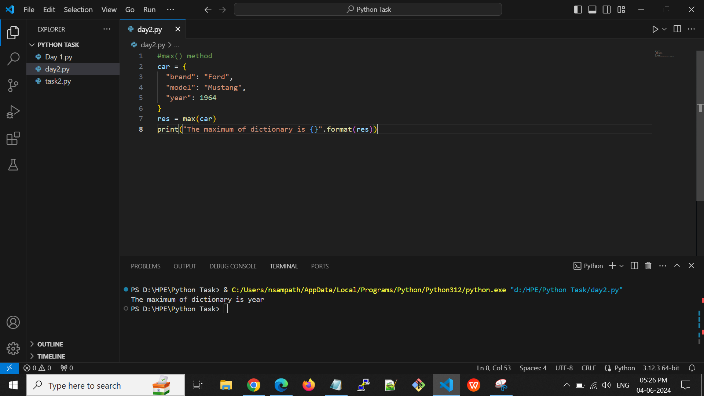

**Output:**

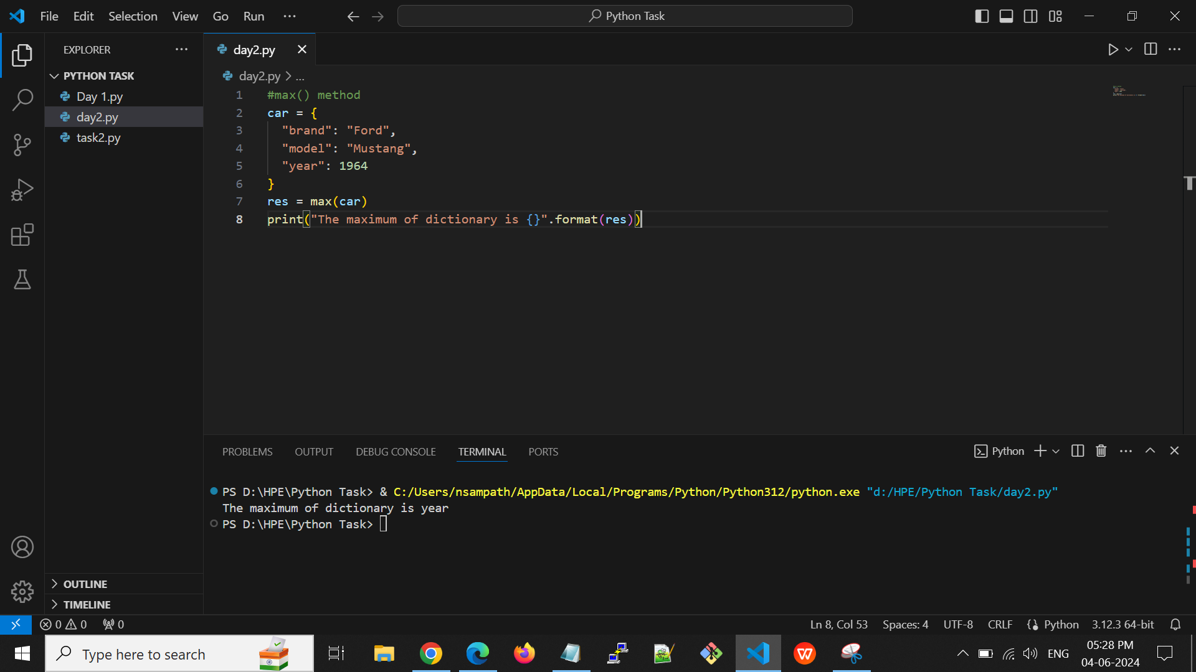

**min() -** Return minimum key of dictionary

**E.g:**

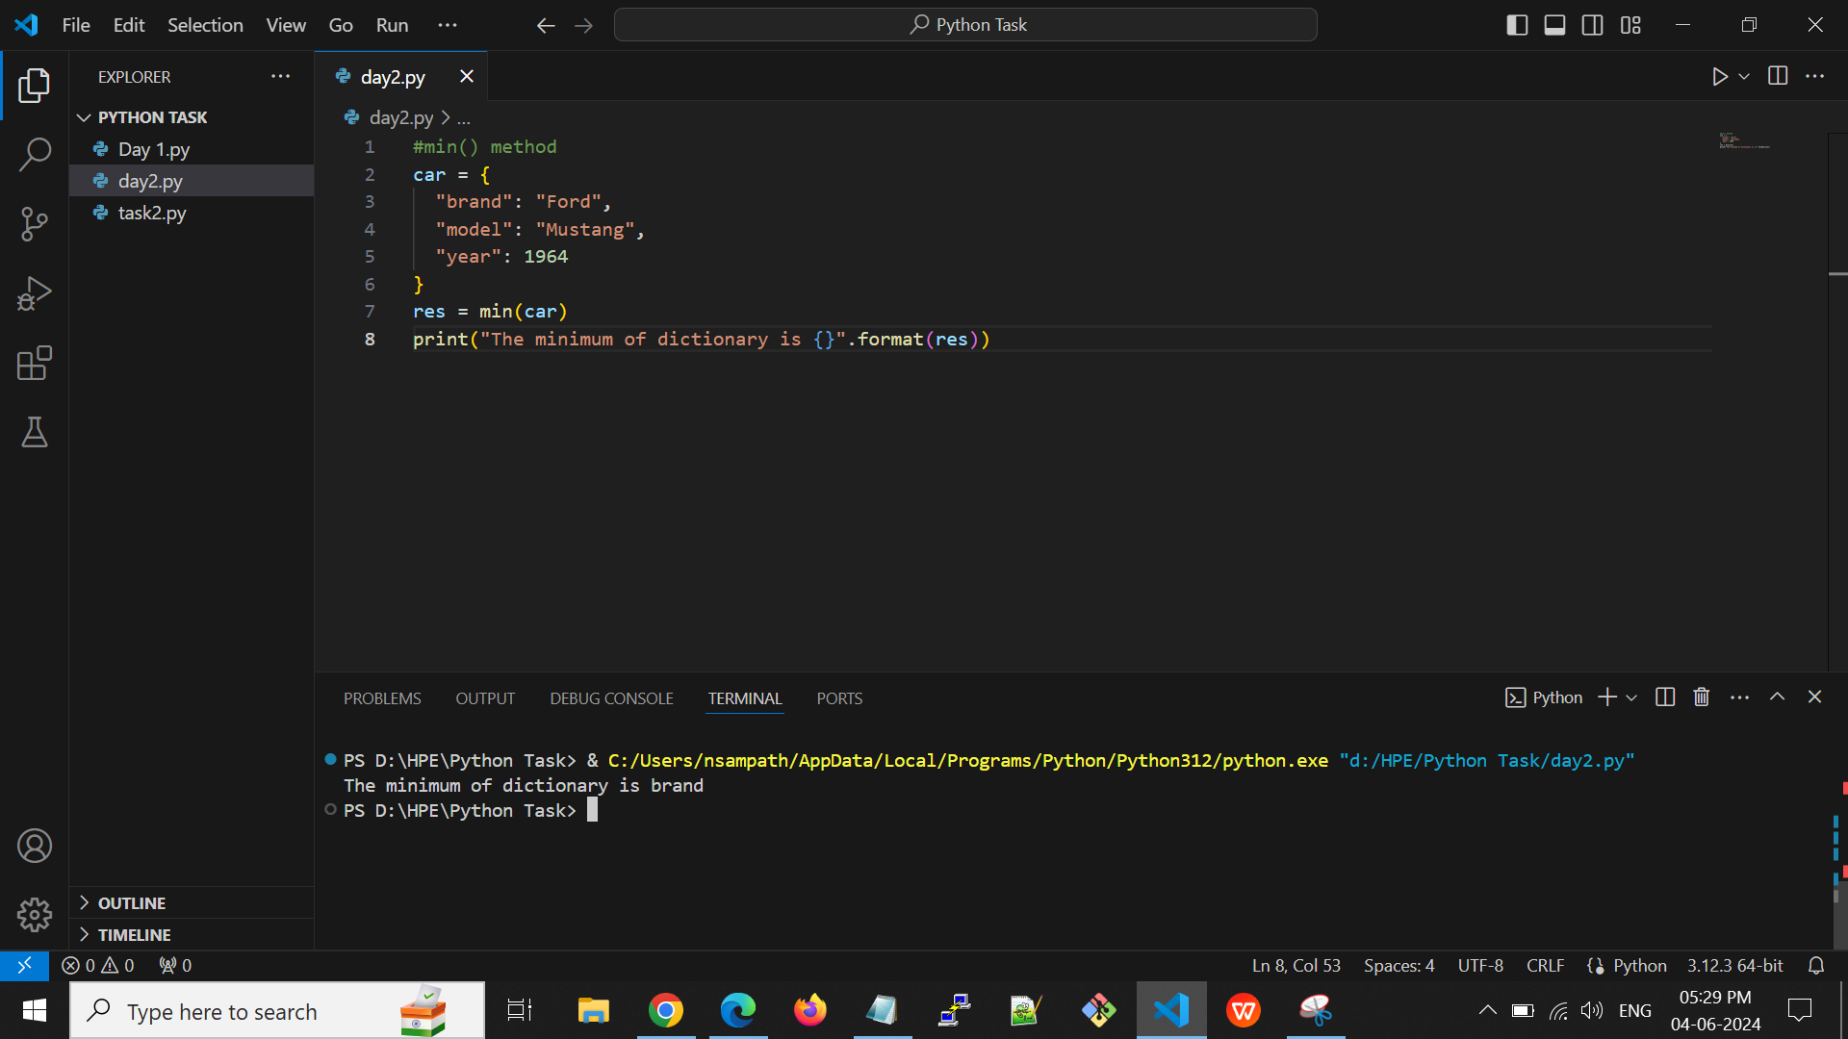

**Output:**



**copy() -** Returns a copy of the dictionary.

**E.g:**

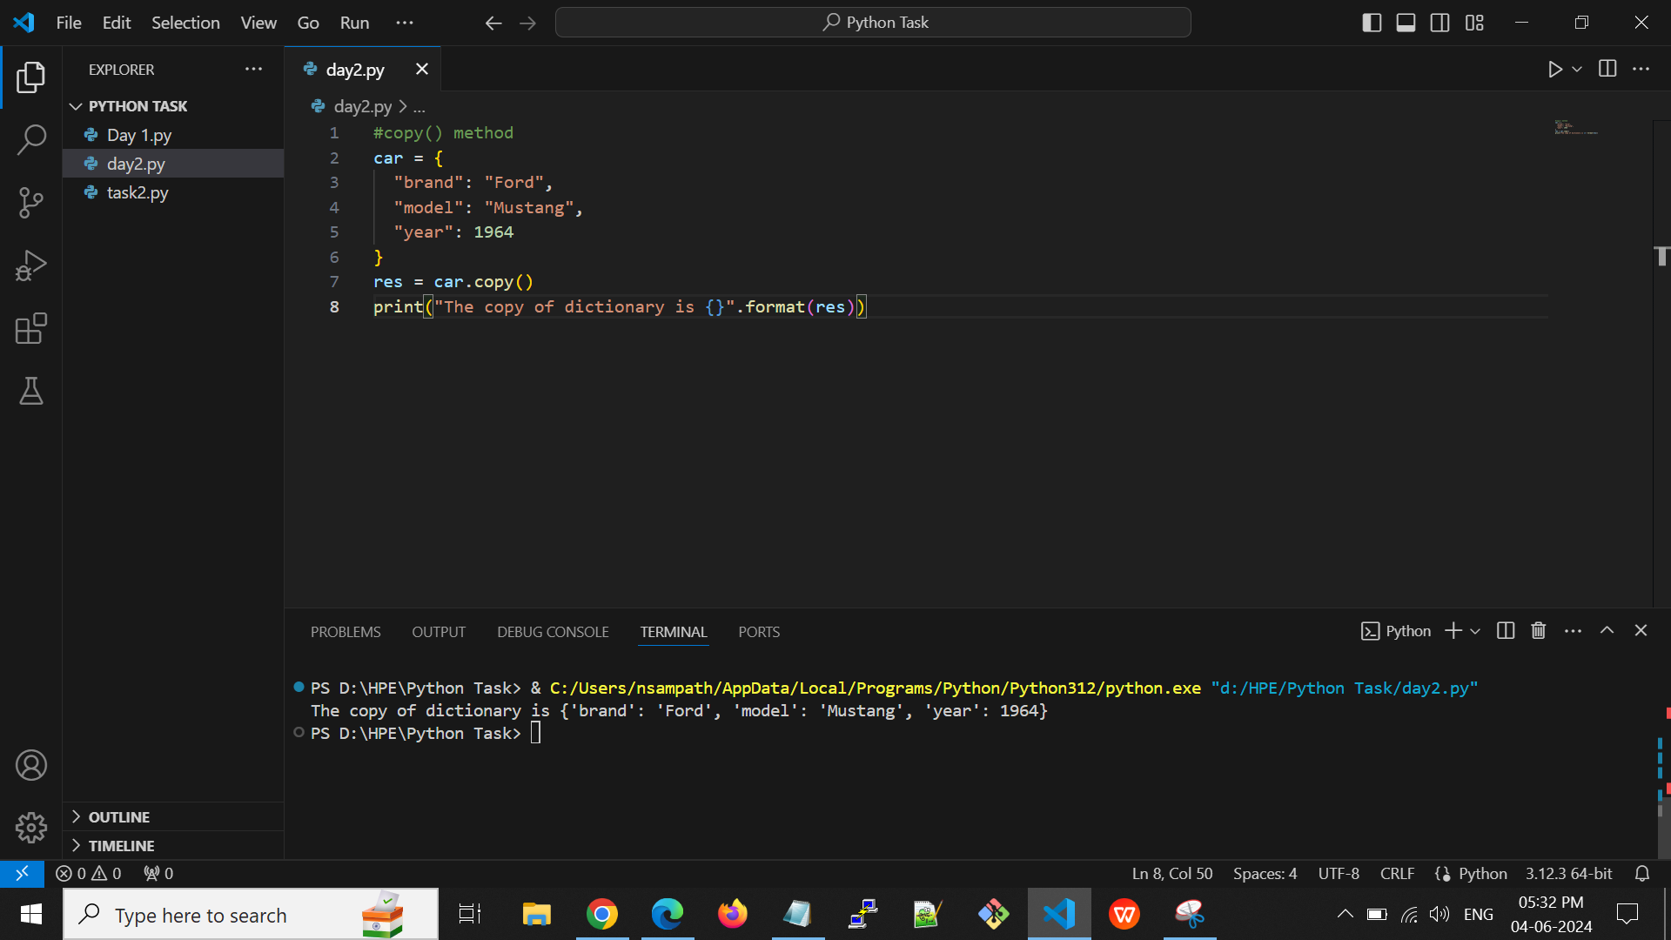

**Output:**



**pop() -** Removes the element with the specified key.

**E.g:**

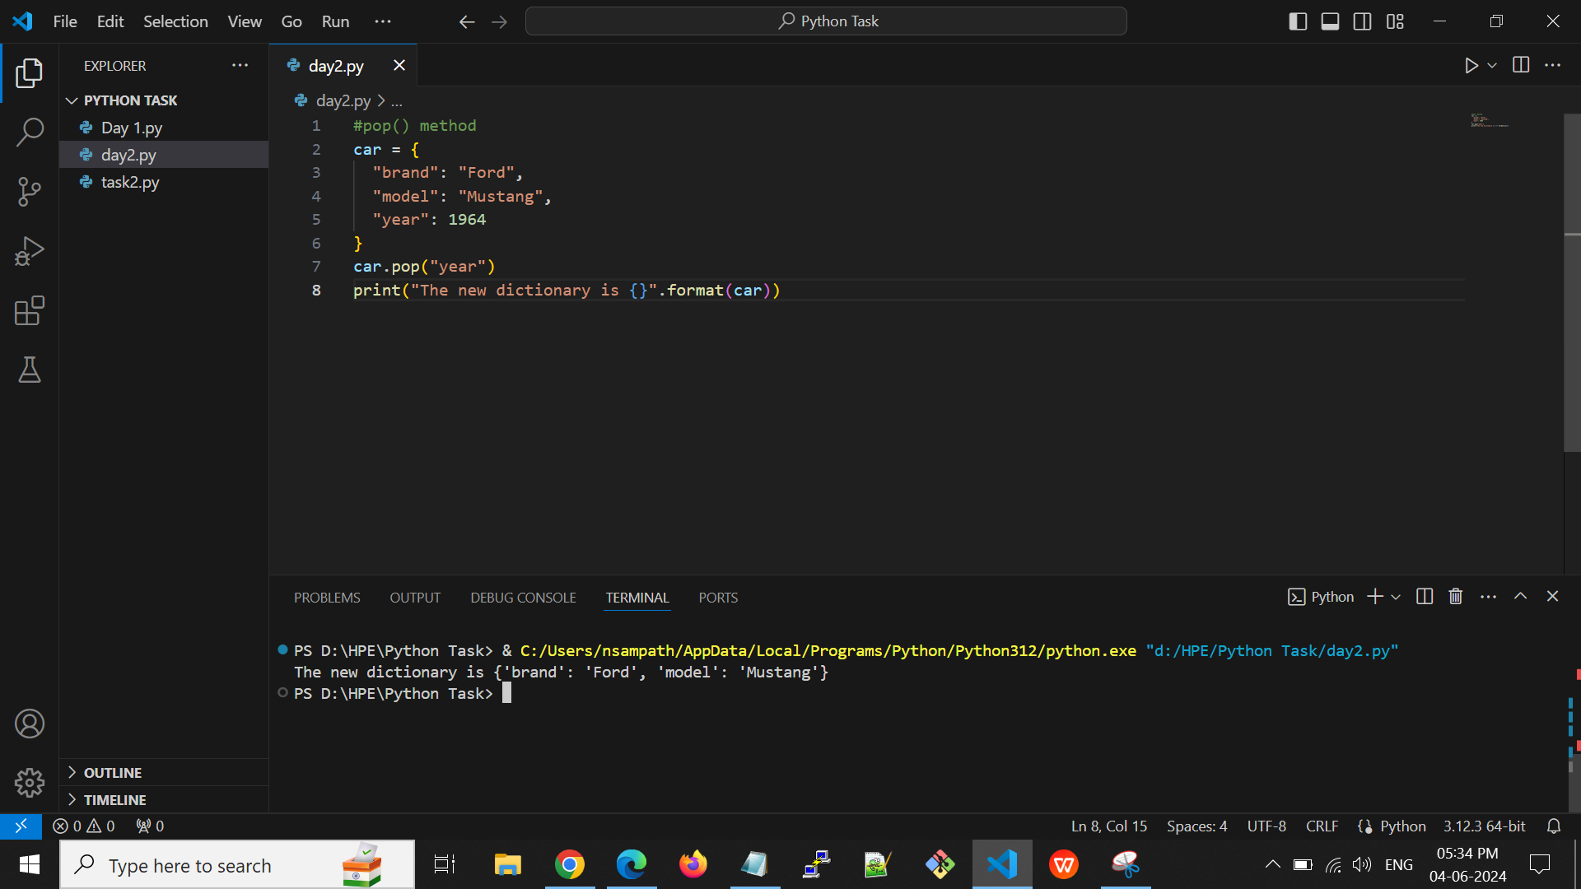

**Output:**



**keys() -** Returns a list containing the dictionary's keys.

**E.g:**

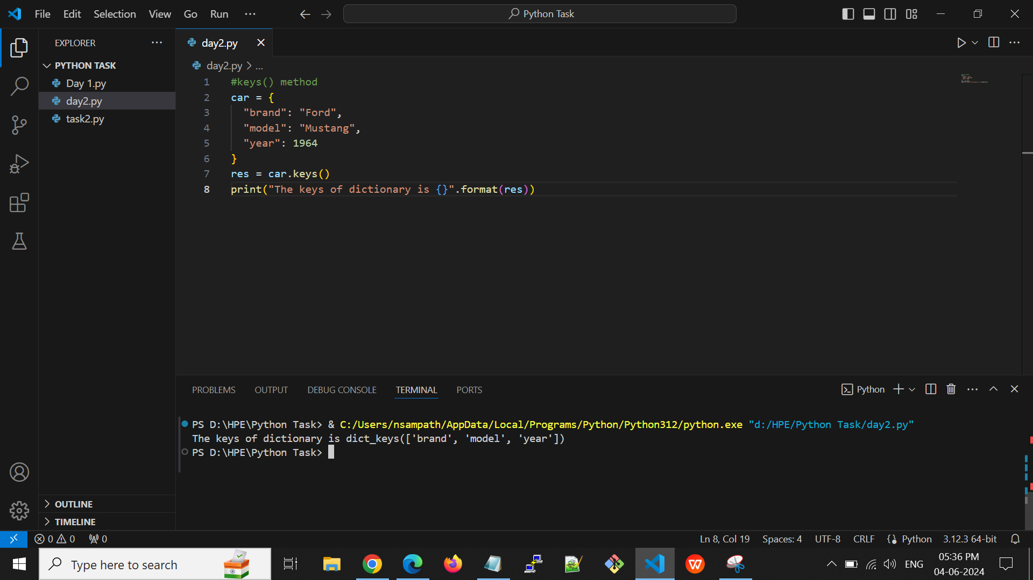

**Output:**



**values() -** Returns a list of all the values in the dictionary.

**E.g:**

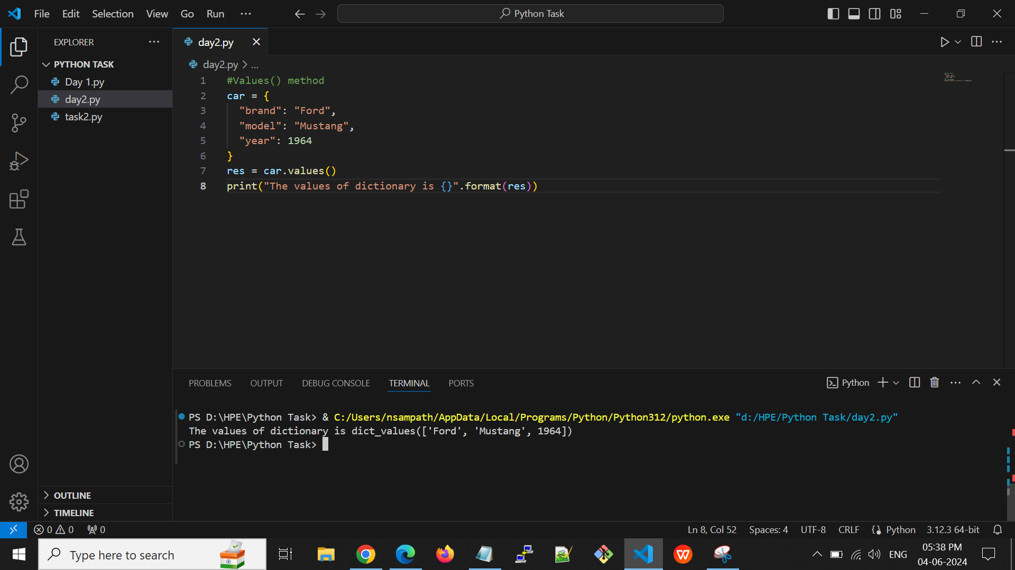

**Output:**



**Python Operators:-**

The operator is a symbol that performs a specific operation between two operands, according to one definition.

* **+ (Addition)** - It is used to add two operands.
* **- (Subtraction)** - It is used to subtract the second operand from the first operand. If the first operand is less than the second operand, the value results negative.
* **/ (divide)** - It returns the quotient after dividing the first operand by the second operand.
* **\* (Multiplication)** - It is used to multiply one operand with the other.
* **% (reminder)** - It returns the remainder after dividing the first operand by the second operand.
* **\*\* (Exponent)** - As it calculates the first operand's power to the second operand, it is an exponent operator.
* **// (Floor division)** - It provides the quotient's floor value, which is obtained by dividing the two operands.

**E.g:**

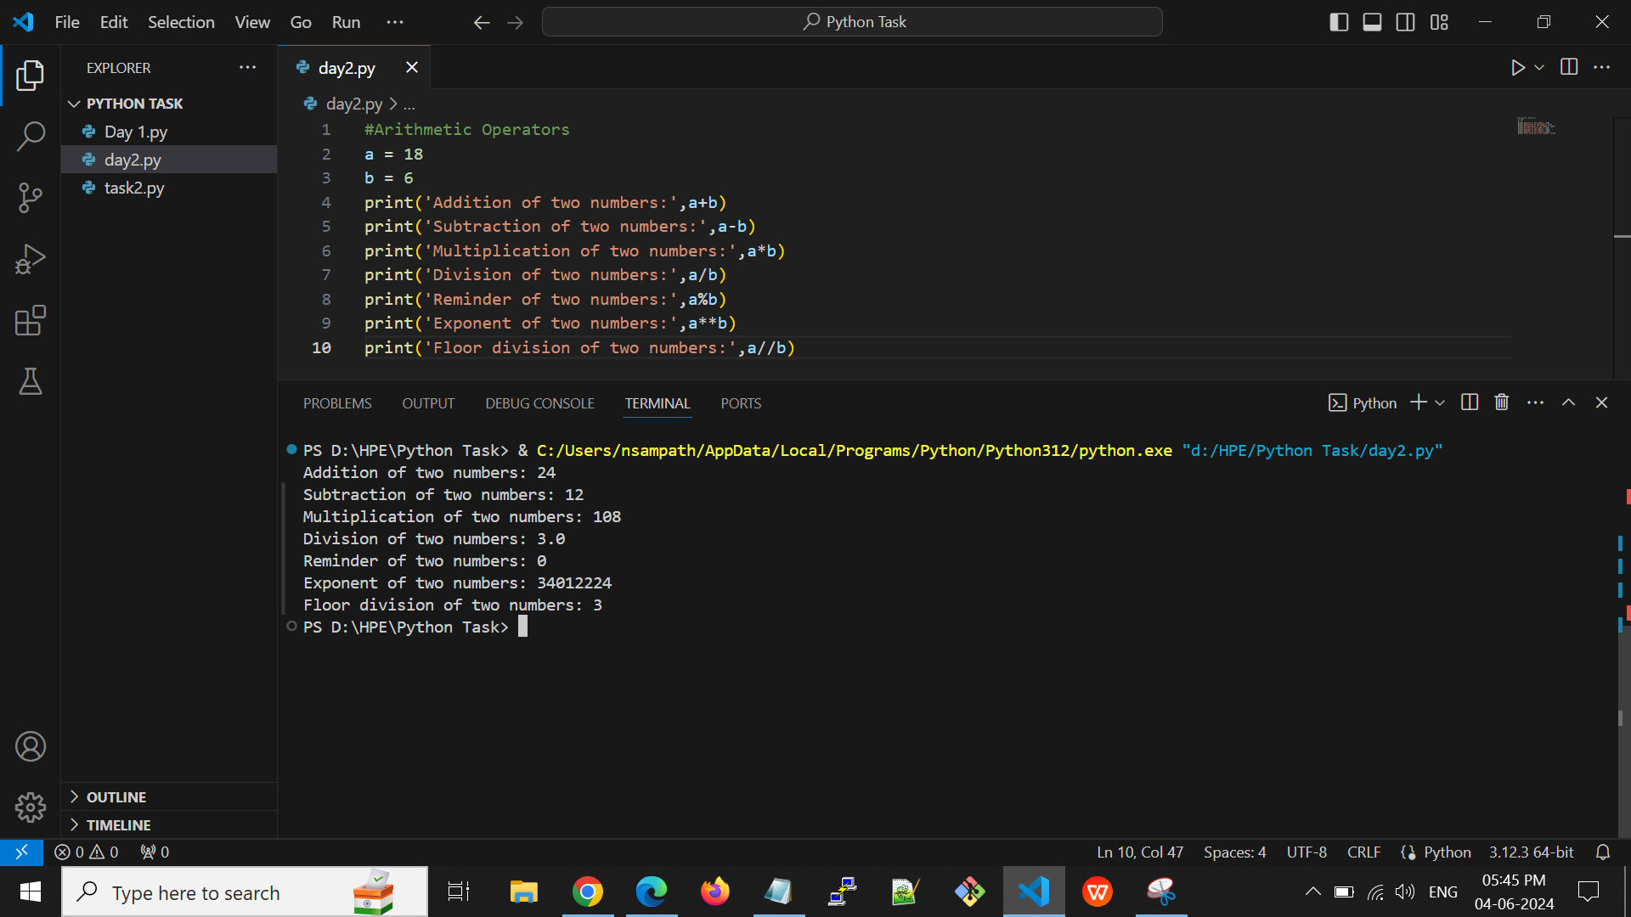

**Output:**



**Comparison operator:**

Comparison operators mainly use for comparison purposes. Comparison operators compare the values of the two operands and return a true or false Boolean value in accordance.

* **==** - If the value of two operands is equal, then the condition becomes true.
* **!=** - If the value of two operands is not equal, then the condition becomes true.
* **<=** - The condition is met if the first operand is smaller than or equal to the second operand.
* **>=** - The condition is met if the first operand is greater than or equal to the second operand.
* **>** - If the first operand is greater than the second operand, then the condition becomes true.
* **<** - If the first operand is less than the second operand, then the condition becomes true.

**E.g:**

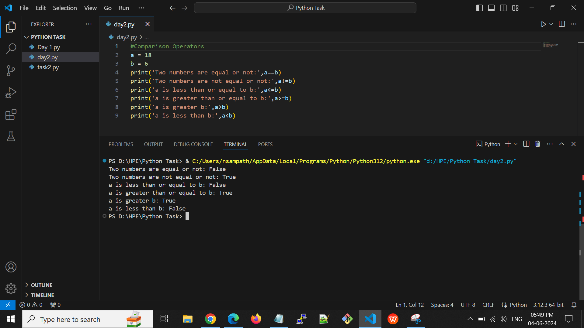

**Output:**



**Assignment Operators:-**

Using the assignment operators, the right expression's value is assigned to the left operand.

* **=** - It assigns the value.
* **+=** - It adding the value of the left operand by the value of the right operand
* **-=** - It decreases the value of the left operand by the value of the right operand
* **\*=** - It multiplies the value of the left operand by the value of the right operand
* **%=** - It divides the value of the left operand by the value of the right operand.
* **\*\*=** - a**=b will be equal to a=a**b.
* **//=** - A//=b will be equal to a = a// b.

**E.g:**

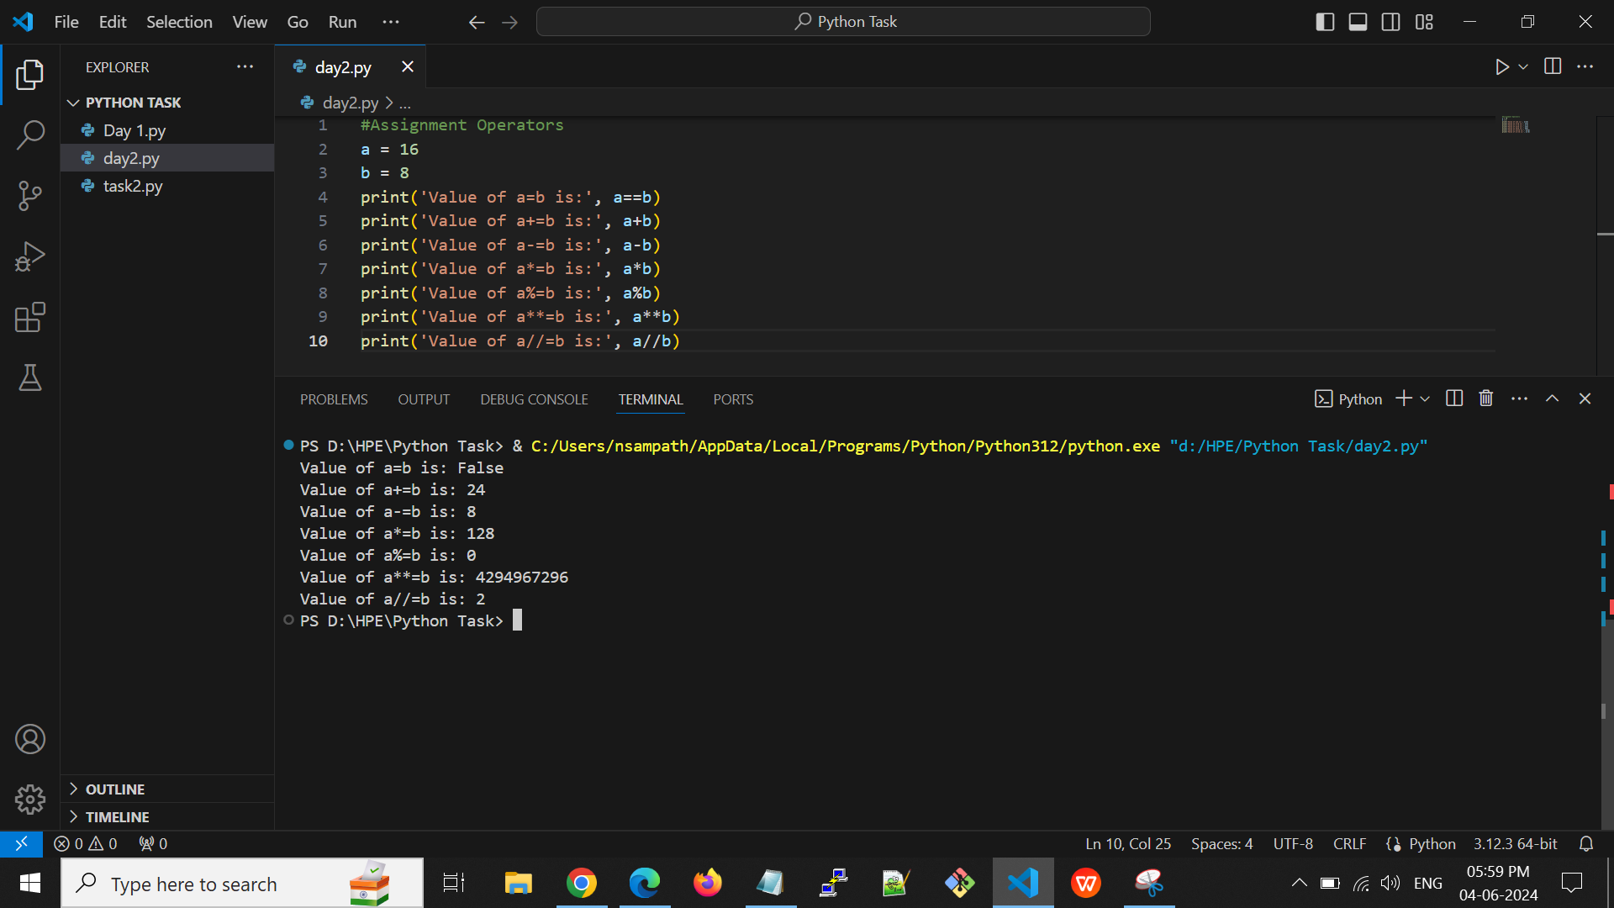

**Output:**



**Bitwise Operators:-**

**The two operands' values are processed bit by bit by the bitwise operators.**

* **& (binary and)** - A 1 is copied to the result if both bits in two operands at the same location are 1. If not, 0 is copied.
* **| (binary or)** - The resulting bit will be 0 if both the bits are zero; otherwise, the resulting bit will be 1.
* **^ (binary xor)** - If the two bits are different, the outcome bit will be 1, else it will be 0.
* **~ (negation**) - The operand's bits are calculated as their negations, so if one bit is 0, the next bit will be 1.
* **<< (left shift)** - The number of bits in the right operand is multiplied by the leftward shift of the value of the left operand.
* **>> (right shift)** - The left operand is moved right by the number of bits present in the right operand.

**E.g:**

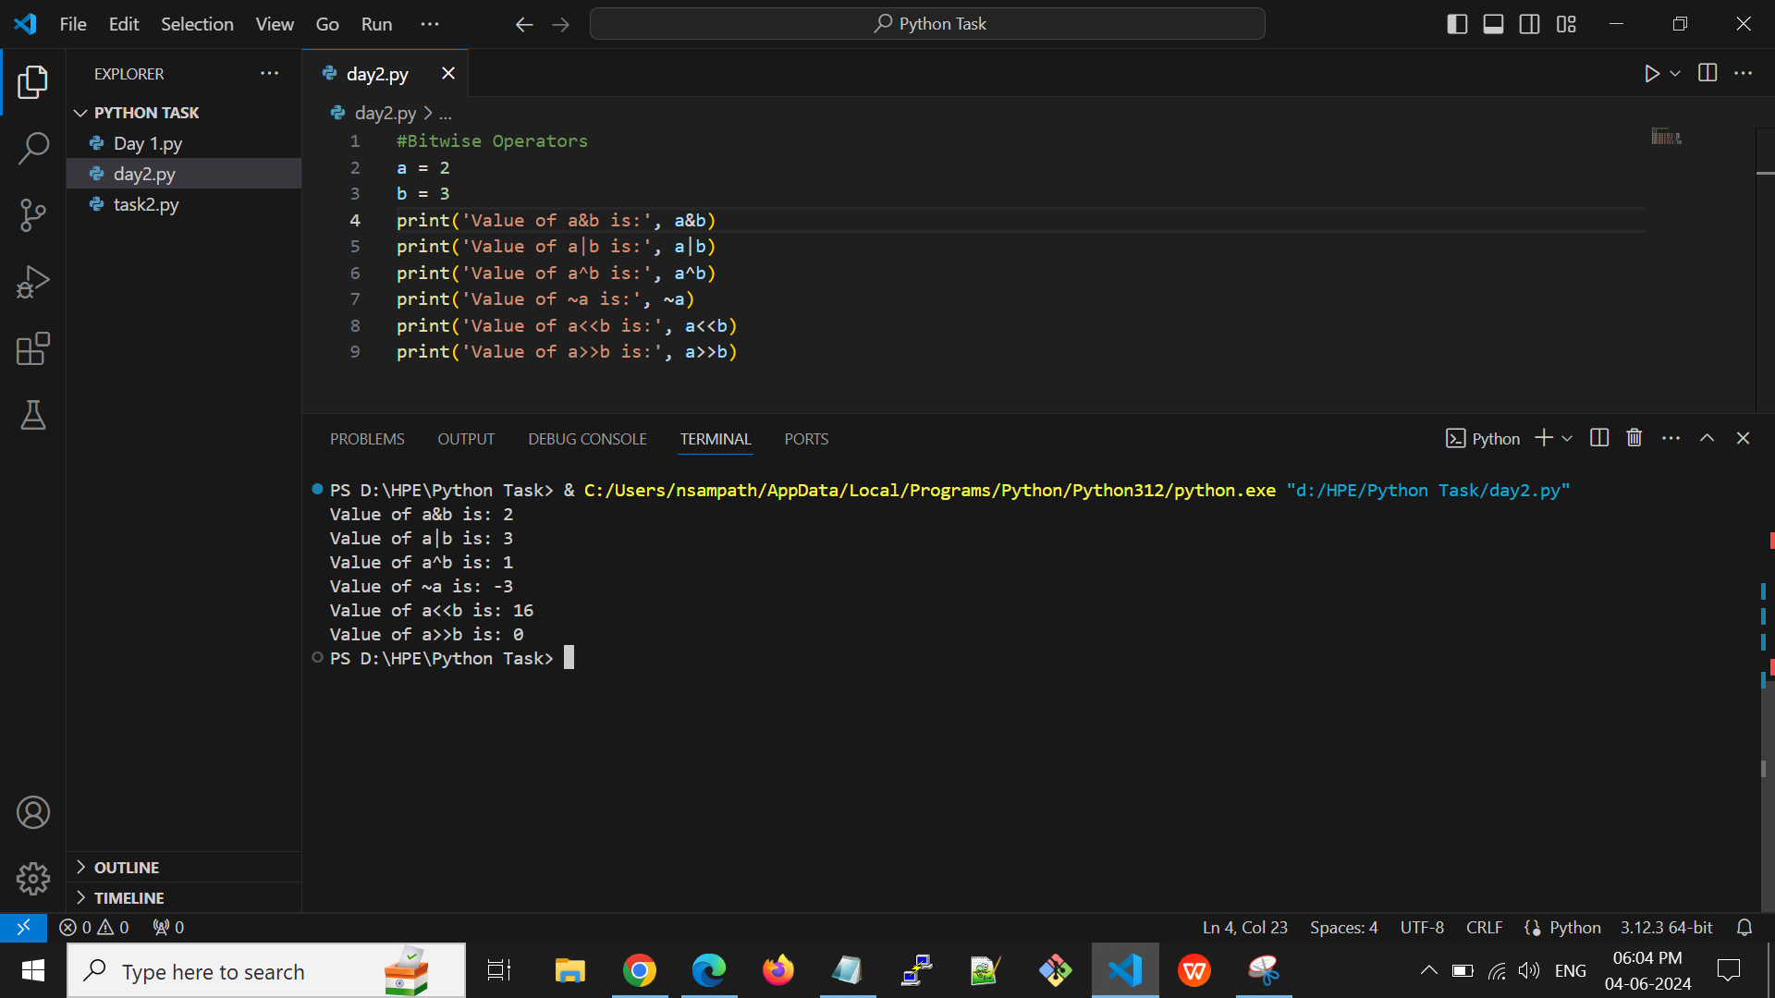

**Output:**



Membership Operators:-

The result is true if the value is in the data structure; otherwise, it returns false.

* **in** - If the first operand cannot be found in the second operand, it is evaluated to be true.
* **not in** - If the first operand is not present in the second operand, the evaluation is true.

**E.g:**

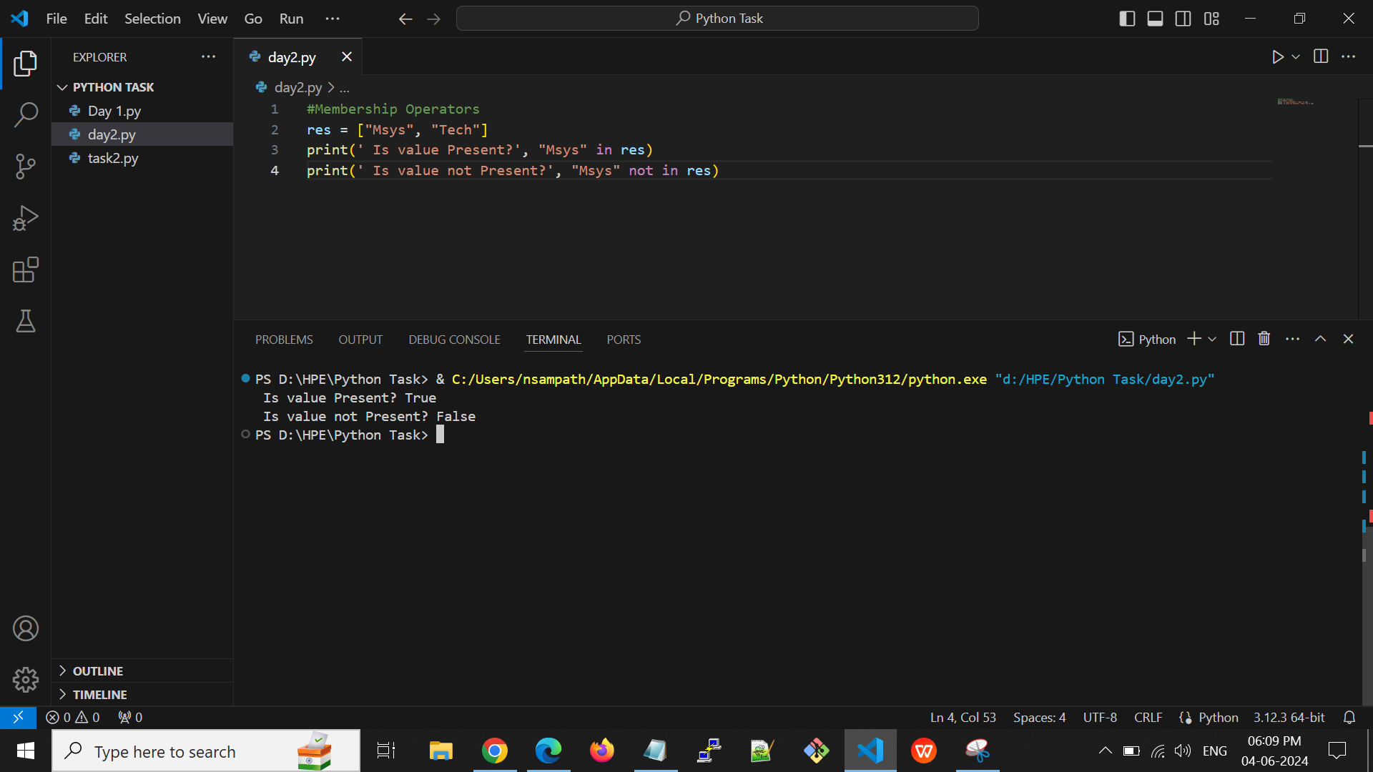

**Output:**



**Identity Operators:-**

The result is true if the both values are the same; otherwise, it returns false.

* **is** - If the references on both sides point to the same object, it is determined to be true.
* **is not** - If the references on both sides do not point at the same object, it is determined to be true.

**E.g:**

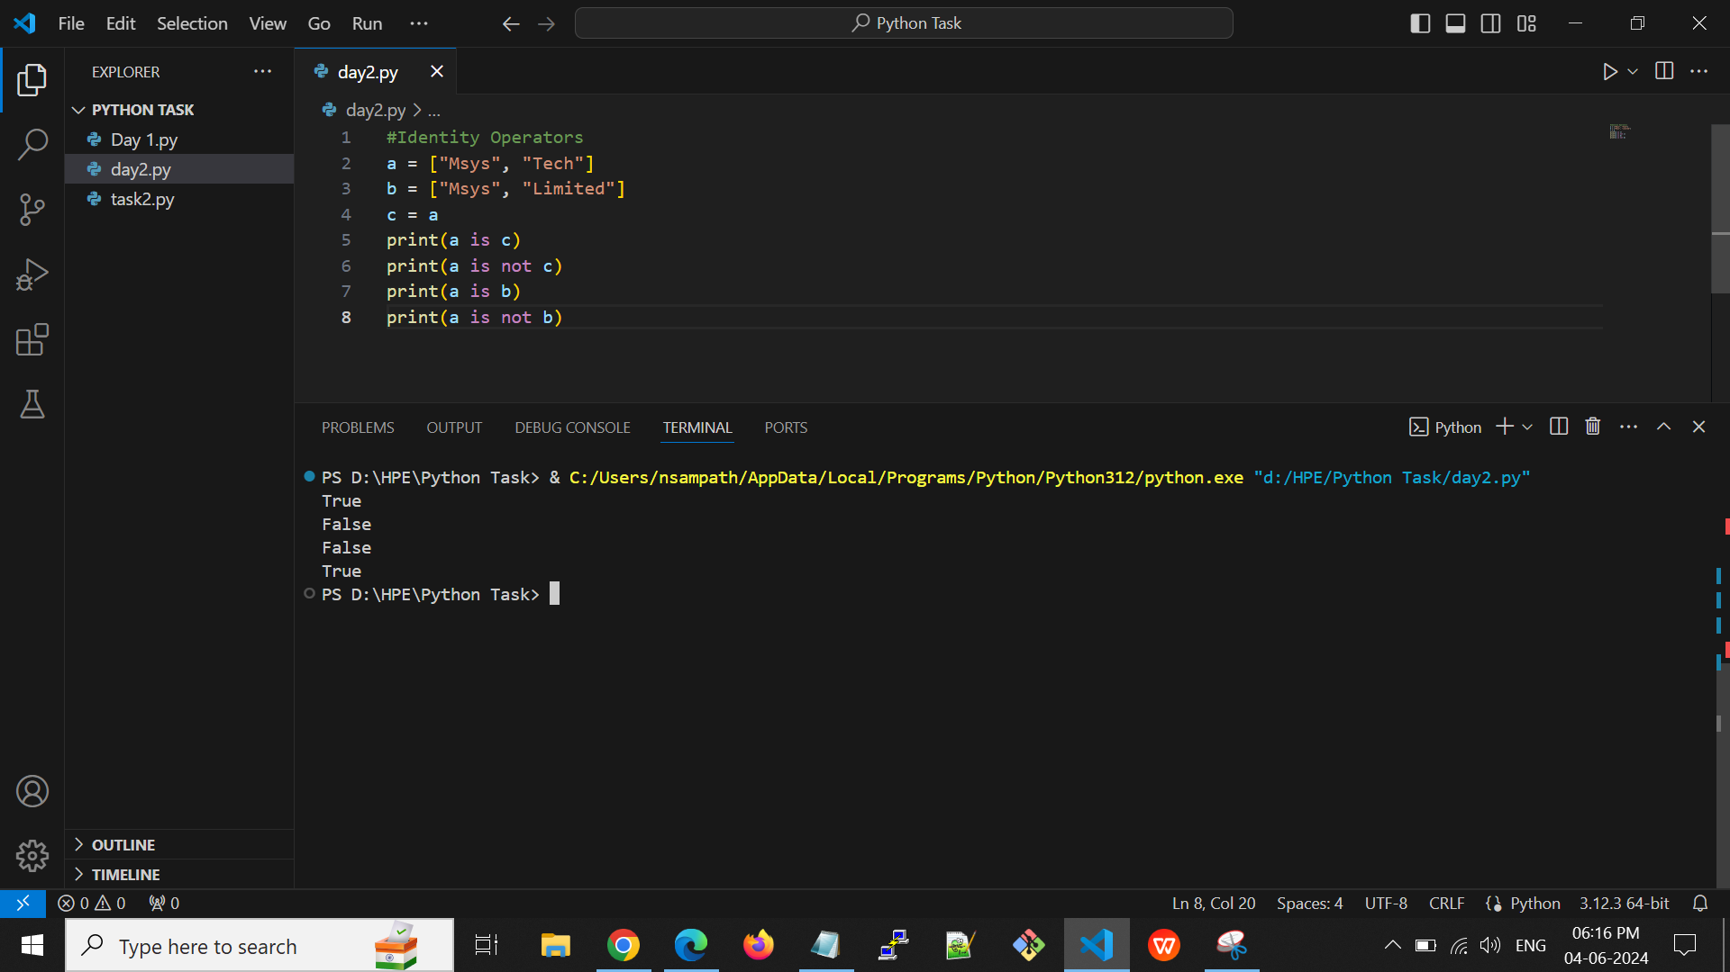

**Output:**



**Python Day 3:-**

**Python Decision making:-**

Decision making allows us to run a particular block of code for a particular decision.

* If Statement
* If else Statement
* Elif statement
* Nested if Statement

**If Statement:-**

The if statement is used to test a specific condition. If the condition is true, a block of code (if-block) will be executed.

**Ifelse Statement:-**

If the condition provided in the if statement is false, then the else statement will be executed.

**elif statement:-**

Elif statement allows to check multiple conditions and executing the specific block of statements depending upon the true condition among them.

**Nested if Statement:-**

if statements have inside if statements called nested if statements.

**Python Iterations:-**

We can run a single statement or set of statements repeatedly using a loop command.

* For loop
* While loop
* Nested loops

**For loop:-**

For loop is used for iterating over an iterable like a String, Tuple, List, Set, or Dictionary.

**While loop:-**

Repeats a statement or group of statements while a given condition is true. It tests the condition before executing the loop body.

**Nested loops:-**

We can iterate a loop inside another loop.

**Break:-**

This command terminates the loop's execution and transfers the program's control to the statement next to the loop.

**Continue:-**

This command skips the current iteration of the loop. The statements following the continue statement are not executed once the Python interpreter reaches the continue statement.

**Pass:-**

Pass statements are used to create empty loops.

**Python Functions:-**

* A function is a block of code which only runs when it is called.
* A function can return data as a result.
* In Python a function is defined using the def keyword.
* To call a function, use the function name followed by parenthesis.

**Keyword Arguments:-**

You can also send arguments with the key = value, for example function_name( a = 50, b = 30).

**Default Arguments:-**

If we call the function without argument, it uses the default value, for example function_name( 50,30).

**Arbitrary Arguments:-**

If you do not know how many arguments that will be passed into your function, add a * before the parameter name in the function definition, for example def function_name(*args).